***Arab American University***

***Faculty of Engineering and Information Technology***

***Computer Systems Engineering***

**SENIOR PROJECT II**

*Distributed modules for large landscape weather data collection*

*2023/2024*

|  |
| --- |
| Supervised by: *Dr. Tareq Zanoon* |

|  |
| --- |
| **Computer Systems Engineering Dept.**  **Submitted in partial fulfillment of the requirements of B.Sc. Degree in Computer Systems Engineering**  ***Feb 2024*** |

**Students Statement**

We, the undersigned students, certify and confirm that the work submitted in this project report is entirely our own and has not been copied from any other source. Any material that has been used from other sources has been properly cited and acknowledged in the report.

We are fully aware that any copying or improper citation of references/sources used in this report will be considered plagiarism, which is a clear violation of the Code of Ethics of the Arab American University.

|  |  |
| --- | --- |
| Mohammad Abu Malash -201911801 | Adel Azem-201812260 |
|  |  |
|  |  |
| Moath Abu Malash -201912230 |  |

**Supervisor Certification**

This to certify that the work presented in this senior year project manuscript was carried out under my supervision, which is entitled:

“**Distributed modules for large landscape weather**”

|  |  |
| --- | --- |
| *Mohammad Abu Malash - 201911801* | *Adel Azem - 201812260* |
| *Moath Abu Malash - 201912230* |  |

I hereby that the aforementioned students have successfully finished their senior year project and by submitting this report they have fulfilled in partial the requirements of B.Sc. Degree in Computer System Engineering.

I also, hereby that I have **read, reviewed, and corrected the technical content** of this report and I believe that it is adequate in scope, quality, and content and it is in alignment with the ABET requirements and the department guidelines.

*Dr. Tareq Zanoon,*

**ACKNOWLEDGMENT**

Praise be to God, Lord of the worlds, and prayers and peace be upon the most honorable of the prophets and messengers, our master Muhammad, his family and companions, and those who followed them in goodness until the Day of Judgment.

First and foremost, we thank God for His blessings on us, and on our behalf, we succeeded in this endeavor. We also pray for the knowledge we gain to be useful to the rest of the world, especially to Palestine.

Then we thank those kind people who extended a helping hand to me during this period, headed by **Dr. Tariq Zanoon**, who spared no effort in helping us.

We would like to thank our families for the continued support and the encouragement they gave us from start to finish moment.

We thank the dear doctors in the Department of Computer Engineering, who get the credit for reaching this stage with everything they've got gave us all these years, we will be forever grateful.

To all those and others who have supported us through thick and thin, we offer a big "thank you" straight from our hearts, we bring to you this report and project.

**ABSTRACT**

In this project, a system of cheap and solar-powered mobile whether data collection modules is proposed and designed to measure and report weather-related parameters. such as the amount of rainfall, temperature, and wind speed. The proposed system is proposed to span a wide geographical landscape, where module units communicate with other identical units to provide the required connectivity for data reporting. To demonstrate this, this project utilizes two module units where connectivity, location, data reporting, maps, and statistical graphs are implemented and tested. The expandability of further modules (nodes) is an integral part of the system design.

**Keywords:** Sensors, Mobile communication, Weather forecasting, Data network, Weather data collection.

**TABLE OF CONTENTS**

**LIST OF FIGURES** v

**LIST OF TABLES** vi

**LIST OF SYMBOLS AND ABBREVIATIONS** viii

**1** **CHAPTER 1: INTRODUCTION** 1

1.1 Problem Statement and Purpose 1

1.2 Project and Design Objectives 1

1.3 Intended Outcomes and Deliverables 2

1.4 Summary of Report Structure 2

**2** **CHAPTER 2: BACKGROUND** 3

2.1 Overview 3

2.2 Related Work 3

2.2.1 Citizen Weather Observer Program 3

2.2.2 Netatmo Weather Station 3

2.2.3 Froggit HP1000SE Pro 4

2.2.4 IMETOS 3.3 Automatic station and data logger 5

2.2.5 Weather Drones - Meteorological Data from the Base Layer 6

**3** **CHAPTER 3: METHODS AND MATERIALS** 7

3.1 System Design and Components 7

3.1.1 Arduino Uno 9

3.1.1.1 Data logger 9

3.1.2 Tipping Bucket 11

3.1.3 Anemometer 12

3.1.4 Wireless Transmission 13

3.1.4.1 XBee S2C 14

3.1.4.2 Wi-Fi Transmutation 16

3.1.5 NEO-6M GPS receiver 16

3.1.6 Temperature Sensor 17

3.1.7 Humidity Sensor 18

3.1.8 Solar Power System 18

3.1.9 Stations Placement and Data Transmission 19

3.1.10 System Application 19

3.2 Design Specifications, Standards, and Constraints 20

3.2.1 Specifications 20

3.2.2 Standards 20

3.2.3 Constraints 21

3.3 Design Alternatives 21

3.3.1 The microcontroller 21

3.3.2 The Communication Module. 21

3.3.3 Data-sharing 22

3.4 System Analysis and Optimization 22

3.4.1 Hardware and software integration 22

3.4.1.1 Temperature Sensor (DS18B20) 22

3.4.1.2 Humidity Sensor (DHT-22) 24

3.4.1.3 Wind Speed Sensor 25

3.4.1.4 Rain Fall Sensor 26

3.4.1.5 System Flowchart 28

3.4.2 System application 31

3.4.2.1 Product Functions 31

3.4.2.2 System Features (Functional Requirements Detailed) 31

3.4.2.3 Dashboard 31

3.4.2.4 Map-based interface 32

3.4.2.5 Information visualization 32

3.4.2.6 Information visualization 32

3.4.2.7 Alerts and Notifications 32

3.4.3 ER Digram 33

3.4.4 Schema 34

*3.5* Simulation and/or Experimental Test 34

3.5.1 Hardware 34

3.5.1.1 Budling the Network 34

3.5.1.2 Sensors 39

3.5.1.3 All together 41

3.5.2 Other features the project provide 43

3.5.3 Storing the Data on the Cloud service (The software) 44

**4** **HAPTER 4: RESULTS AND DISCUSSIONS** 46

4.1 Results 46

4.2 Discussions 50

**5** **CHAPTER 5: Project Management** 51

5.1 Tasks, Schedule, and Milestones 51

5.2 Resources and Cost Management 52

*5.3* Lessons Learned 53

**6** **CHAPTER 6: Impact of the engineering solution** 55

6.1 Economical, Societal, and Global 55

6.2 Environmental and Ethical 56

**7** **CHAPTER 7: CONCLUSIONS and RECOMMENDATIONS** 57

7.1 Summary of Achievements of the Project Objectives 57

7.1.1 Build a Weather Monitoring Module with Solar-Powered Mobile Units 57

7.1.1.1 Sensor Integration: 57

7.1.1.2 Wireless Communication: 57

7.1.1.3 Geographical Positioning: 57

7.1.1.4 Solar Power Implementation: 57

**7.1.2** **Develop an application for real-time data visualization.** 57

**7.1.3** **Ensure seamless communication network.** 58

**7.2** **New Skills and Experiences Learnt** 58

***7.3*** **Recommendations for Future Work** 58

**LIST OF FIGURES**

*Figure Page*

Figure 2- 1: Froggit HP1000SE Pro [5] 4

Figure 2- 2:IMETOS 3.3 Automatic station and data logger [7] 5

Figure 2- 3:Weather Drone [8] 6

Figure 3- 1: Components 8

Figure 3- 2: Block Diagram for the Sub Stations 8

Figure 3- 3: Data logger parts [11] 9

Figure 3- 4:pin Location of communication protocols [11] 10

Figure 3- 5:Tipping buckets design [15] 11

Figure 3- 6: Flat Bearing Center 13

Figure 3- 7: Full image of the anemometer 13

Figure 3- 8:generic Zigbee network [19] 14

Figure 3- 9:Mesh Network of Stations 15

Figure 3- 10:Block Diagram for the Base Weather Station 16

Figure 3- 11:Temperature register format [25] 18

Figure 3- 12:DS18B20 pins [30] 23

Figure 3- 13: DS18B20 Flowchart 23

Figure 3- 14: DHT-22 pins [31] 24

Figure 3- 15:Humidity Flowchart 24

Figure 3- 16: Opto sensor Components [32] 26

Figure 3- 17:Rainfall Flowchart 27

Figure 3- 18:Sender Side flowchart 29

Figure 3- 19:Receiver Side flowchart 29

Figure 3- 20: System Flowchart 30

Figure 3- 21:ER Diagram 33

Figure 3- 22: Project Schema 34

Figure 3- 23: Circuit-Diagram-for-XBee-Module-Interfacing-with-Arduino [33] 35

Figure 3- 24: XCTU interface for Coordinator configuration 36

Figure 3- 25: Enabling API mode for the Xbee 36

Figure 3- 26:Xbee Configuration as a Router 37

Figure 3- 27: New Xbee to Arduino connection [34] 38

Figure 3- 28: Buckets and Base [35] 40

Figure 3- 29: Case [35] 41

Figure 3- 30: Full Sensor [35] 41

Figure 5- 1: Gantt Chart and TimeLine 51

Figure 5- 2: Gantt Chart and TimeLine 52

**LIST OF TABLES**

*Table Page*

Table 3- 1: DS18B20 to the Arduino [30] 23

Table 5- 1: Resources and Cost 52

**LIST OF SYMBOLS AND ABBREVIATIONS**

|  |  |
| --- | --- |
| **LIST OF ABBREVIATIONS** | |
| **API** | Application Programming Interface |
| **WNS** | Wireless Network of Sensors |
| **UCS** | Underground cloud Service |
| **UV** | Ultraviolet |
| **GSM** | Global System for Mobile Communications |
| **GPRS** | General Packet Radio Service |
| **GPS** | Global Positioning System |
| **I/O** | Input/Output |
| **PWM** | Pulse Width Modulation |
| **UART** | Universal Asynchronous Receiver-Transmitter |
| **RTC** | Real-Time Clock |
| **CSV** | Comma-Separated Values |
| **I2C** | Inter-Integrated Circuit |
| **SPI** | Serial Peripheral Interface |
| **ADC** | Analog to Digital Converter |
| **LR-WPAN** | Low-Rate Wireless Personal Area Network |
| **PAN ID** | Personal Area Network ID |

1. **CHAPTER 1: INTRODUCTION**

Understanding and monitoring weather patterns across vast geographic regions is essential for various sectors, ranging from agriculture and infrastructure to disaster management and environmental conservation. Real-time insights into weather patterns enable proactive responses to weather-related events, contributing to enhanced safety, resource allocation, and resilience-building efforts in both urban and remote areas. Additionally, comprehensive weather data collection supports scientific research

* 1. Problem Statement and Purpose

Traditional methods of collecting weather data from large areas are not only labor-intensive but also financially burdensome. The manual approach of visiting each area separately for data collection demands extensive time and effort, rendering it inefficient and costly. Moreover, the installation of separate weather stations for data measurement is prohibitively expensive due to the need for complex infrastructure, further escalating overall costs. These challenges underscore the urgent need for innovative solutions that streamline the data collection process, minimize resource expenditure, and enhance overall efficiency.

The development of a distributed unit system for collecting weather data addresses a critical need for timely, accurate, and comprehensive information in areas where traditional monitoring methods fall short. By leveraging mobile units powered by solar energy and equipped with advanced communication capabilities, this system offers a solution tailored to the challenges posed by remote locations with limited access to electricity and internet connectivity.

Furthermore, the utilization of statistical graphs, maps, and weather patterns through a user-friendly interface enhances accessibility and usability. Through the integration of an external Application Programming Interface (API), users gain access to additional services,

* 1. Project and Design Objectives

To build a weather monitoring modules powered by solar energy that collects data in quasi-real-time. These modules are interconnected, forming a wireless network of sensors (WNS) that covers a large area. This network will enable adding or removing modules without affecting the network. Then stores and presents the collected data in various tables, graphs, charts, and heatmaps to assist the user in inquiries and statistics

* 1. Intended Outcomes and Deliverables

1. Weather forecast: Weather forecasting is done by collecting different current weather data from all places across the world. This data is sent to supercomputers, where this data is processed and then results are given [1]. Here, our project will help increase the forecast accuracy by providing the current state of different geographical areas.
2. Science: monitoring weather conditions will improve climate change studies, natural disaster research, environmental research, and climate change studies.
3. Farming: enables farmers to make knowledgeable decisions about irrigation, disease and pest management, planting and harvesting schedules, nutrient management, crop choice, and risk management. As a result, farming practices become more effective, productive, and sustainable.
4. Renewable energy: Renewable energy projects can be planned and implemented more effectively, maximizing the potential for energy generation, by using weather data for site selection [2].
   1. Summary of Report Structure

This report comprises seven essential chapters to investigate and present the project. The first chapter introduces the subject's significance, and research objectives, and outlines the report's structure. The second chapter presents a literature review, summarizing existing findings and identifying research gaps. Chapter three explains the research methodology and data collection techniques. In chapter four, the obtained results are presented with clear visual aids. Chapter Five discusses the expected cost and the management plan, while chapter six proposes practical recommendations based on the study's outcomes. The final chapter, chapter seven, offers a concise conclusion, summarizing key points, and suggesting future research directions. Appendices are included for supplementary materials, if applicable.

1. **CHAPTER 2: BACKGROUND**
   1. Overview

Distributed modules for large landscape weather data collection refer to the use of multiple sensors or data collection stations that are spread out over a large geographical area to gather weather data.

The data collected from these stations is then transmitted to a central server or database for processing and analysis using wireless communication networks.

* 1. Related Work

### Citizen Weather Observer Program

Citizen Weather Observer Program and distributed modules for large landscape weather data collection are two distinct approaches to collecting weather data. Citizen science involves engaging members of the public in scientific research projects, including the collection of weather data using personal weather stations or other devices. Distributed modules for large landscape weather data collection involve the deployment of multiple sensors or data collection stations across a large geographical area to gather weather data. Citizen science projects can involve a large number of participants, and the data collected can provide valuable insights into weather patterns and trends. Distributed modules for large landscape weather data collection can provide more detailed and accurate data over a larger area, making it well-suited for applications such as disaster management, agriculture, and land use planning. Both citizen science and distributed modules for large landscape weather data collection represent valuable approaches to weather data collection, and analysis, and can contribute to a better understanding of weather patterns and their impacts on the environment and society [3].

### Netatmo Weather Station

The Netatmo Weather Station is a personal weather monitoring system that allows users to track local weather conditions both indoors and outdoors. The system includes a main unit that collects data from indoor sensors for temperature, humidity, air quality, and noise levels, as well as an outdoor module that collects data for temperature, humidity, and barometric pressure Overall, the Netatmo Weather Station is a useful tool for individuals who are interested in monitoring and tracking local weather conditions for personal purposes.

Quite expensive can’t do much with the data [4].

### Froggit HP1000SE Pro

Is a weather station that consists of a data reception module and is a wireless weather station. That connects via a router, which will then send the data to a cloud platform called Weather Underground Cloud Service (UCS) [5] [6].

This station measures wind speed, wind direction, temperature, humidity, and ultraviolet (UV) radiation. The station is good for the price, however in order to communicate weather data to UCS, it needs a router with internet connectivity.

our project offers the advantages of remote deployment, wireless communication, and data logging (Memory and backup data).

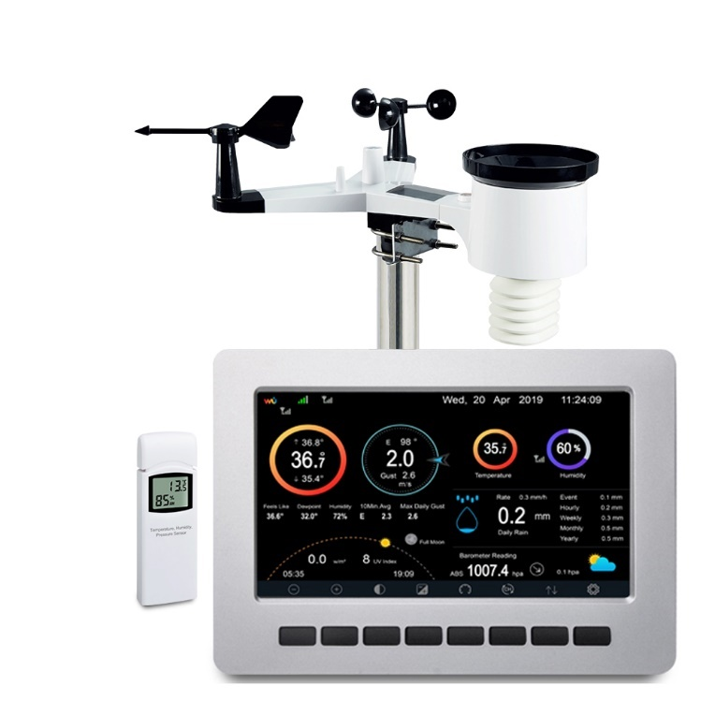

Figure 2- 1: Froggit HP1000SE Pro [5]

### IMETOS 3.3 Automatic station and data logger

The IMETOS 3.3 automatic station and datalogger is a highly robust and versatile weather station specifically designed to operate in diverse environmental conditions. It incorporates non-volatile memory for data storage, establishes communication with various nodes, and facilitates the real-time transmission of weather information via GSM/GPRS technology.

Global System for Mobile Communications (GSM) and General Packet Radio Service (GPRS) are both mobile communication technologies used for transmitting data over cellular networks.

However, a notable drawback of this station is the lack of commercially available and interchangeable sensors, leading to higher costs in the event of sensor failure or damage. Additionally, due to its compact design, these stations require careful consideration when it comes to the maintenance and replacement of small sensors.

Regarding cloud-based communication, the station's connectivity is limited to areas with network coverage. This limitation prompted the initiation of a project aimed at designing and implementing a weather station capable of sensing environmental parameters in regions with challenging network accessibility [7] [6].

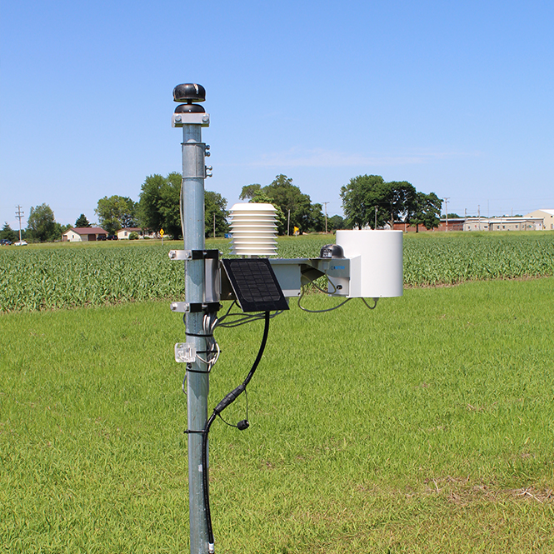

Figure 2- 2:IMETOS 3.3 Automatic station and data logger [7]

### Weather Drones - Meteorological Data from the Base Layer

The use of drones is a major advance in weather data collection compared to traditional data collection methods, as drones can collect data on temperature, humidity, air pressure, wind speed, and direction in different ways, and thus are better equipped for vertical data collection.

Airplanes are designed to counter fluctuations in wind speed but within a limited range. These planes have the advantage of providing readings from hard-to-reach areas. The drone has a storage unit to store the data it collects and sends a data update periodically to the central device.

However, it should be noted that weather drones are subject to certain limitations, such as flight endurance, payload capacity, and regulatory restrictions on airspace use. Drone operations require compliance with local aviation regulations and coordination with meteorological authorities to ensure safe and efficient data collection [8].

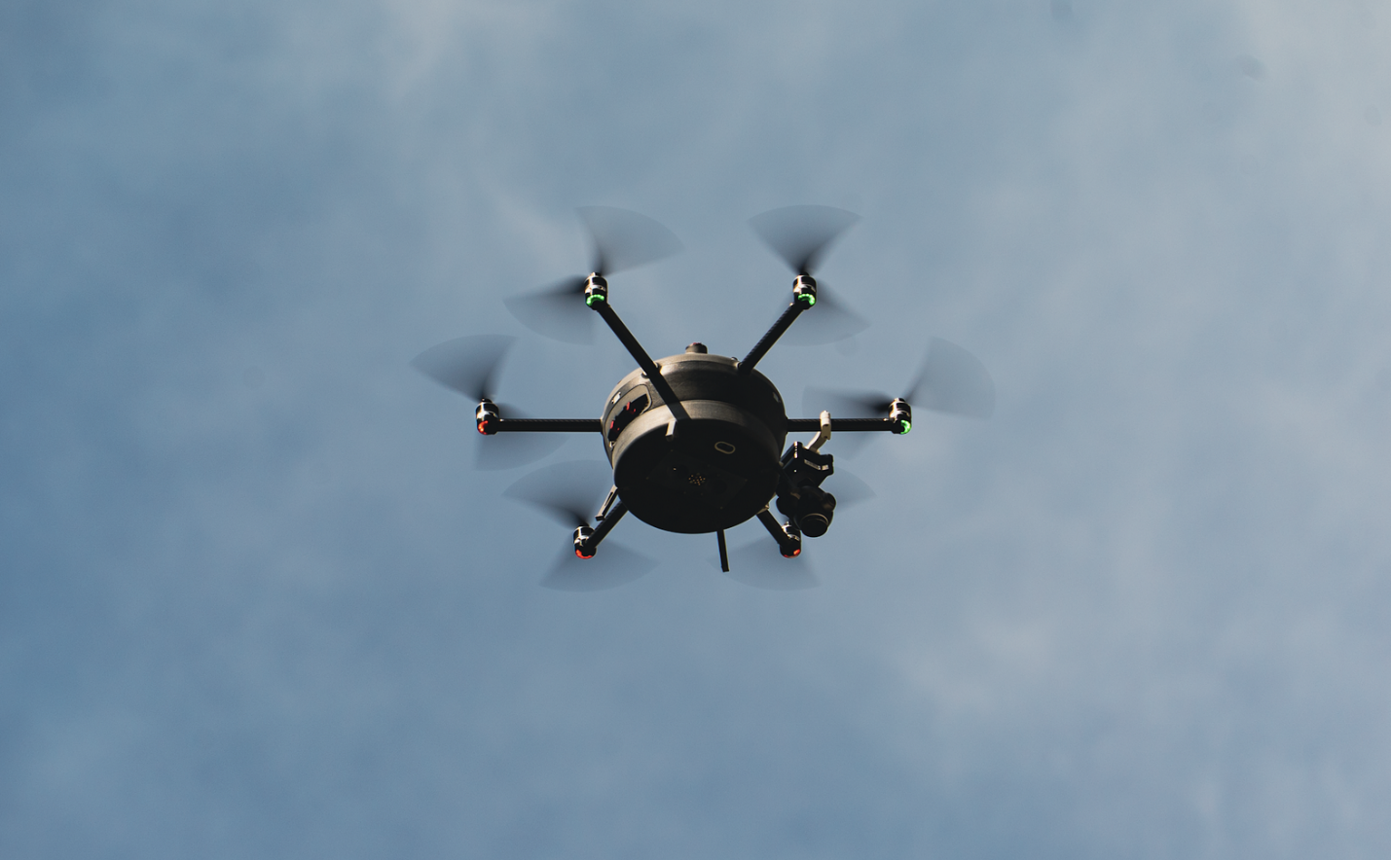

Figure 2- 3:Weather Drone [8]

|  |  |  |  |  |  |  |
| --- | --- | --- | --- | --- | --- | --- |
| System  Compression | Distributed modules  (Our System) | Citizen Weather Observer Program | Netatmo Weather Station | Froggit HP1000SE Pro | IMETOS 3.3 | Weather Drones |
| Network |  |  |  |  |  |  |
| Outdoor |  |  |  |  |  |  |
| Adding more sensors |  |  |  |  |  |  |
| Renewable Energy |  |  |  |  |  |  |
| User Interface |  |  |  |  |  |  |
| Low Cost |  |  |  |  |  |  |
| Affordability |  |  |  |  |  |  |

1. **CHAPTER 3: METHODS AND MATERIALS**
   1. System Design and Components

The project design enables collecting, processing, and communicating weather data using a solar-powered mobile unit. That consists of several main components, including sensors, microcontrollers, communication modules, and GPS. In addition, cloud computing integration is used to store the collected data and send it to an application or user interface.

* The microcontroller serves as the brain of the system, controlling and coordinating the operations of the weather data collection module. It interfaces with various sensors, processes data, and communicates with other modules.
* Sensors: These devices measure weather parameters such as temperature, humidity, rainfall, and wind speed.
* Wireless Communication Module (XBee Pro): Enables communication between the mobile weather data collection module and other modules or devices. It facilitates the transmission of collected data, enabling real-time monitoring and data sharing.
* Global Positioning System (GPS): The integration of GPS functionality allows the modules to determine their precise geographical location. This information is valuable for mapping weather data.
* Solar Power System: The module is powered by a solar power system, which includes solar panels and batteries.
* Data Logger: The data logger allows for automatically recording and storing data from the sensors.
* User Interface and Display: It allows users to access and visualize the collected weather data in quasi-real-time, maps, and statistical graphs.

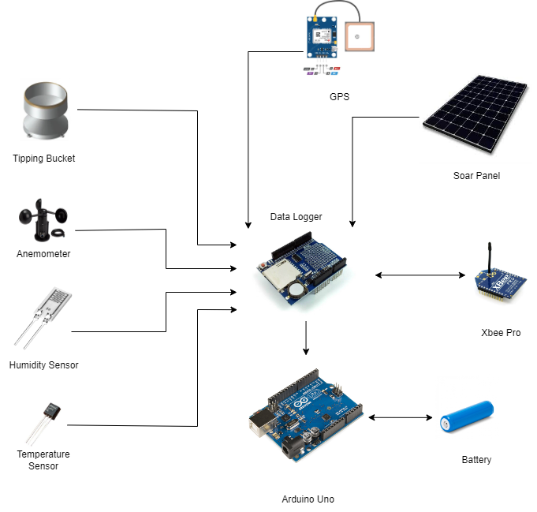

Figure 3- 1: Components

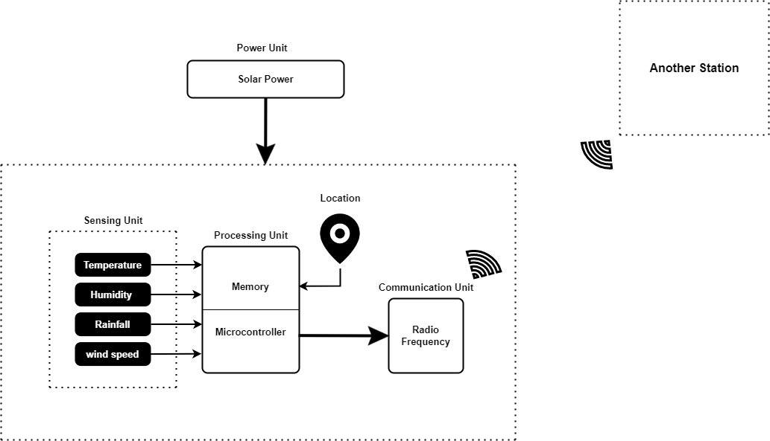

Figure 3- 2: Block Diagram for the Sub Stations

### Arduino Uno

The Arduino Uno is a microcontroller that includes a number of input/output (I/O) pins. The board has 14 digital I/O pins, including 6 that may be used to create pulse width modulation (PWM) signals, and 6 analog I/O pins. The Arduino Uno can receive power from 7 to 20 volts and can be supplied by a USB connection or a barrel connector [9].

With the use of Arduino, we can detect and measure the conditions of the environment using a range of sensors. The microcontroller then processes this information into meaningful data that the user can easily understand.

To share this data, Arduino can send it to a database (Cloud), where it can be accessed and displayed in a user-friendly way through web or mobile applications.

The selection of this microcontroller was based on its sufficient number of available pins to accommodate all the sensors. Additionally, the inclusion of a Universal Asynchronous Receiver-Transmitter (UART) makes it an ideal choice. UART is a widely used communication protocol for connecting devices, allowing data transmission between them. The term "asynchronous" indicates that there is no need for a separate clock signal to synchronize the data transfer between the transmitting and receiving devices [10].

#### Data logger

The data logger shield is an extension board for the Arduino Uno that consists of three main components;

An SD Card Module, a Real-Time Clock (RTC) module, and a prototype board. The data logger designed to automatically record and store data from sensors, capturing and storing data at regular intervals or based on predefined triggers. The data is saved in comma-separated values (.csv) file format [11, 12], which can be easily opened and analyzed in spreadsheet programs like Excel for further analysis and graphing.

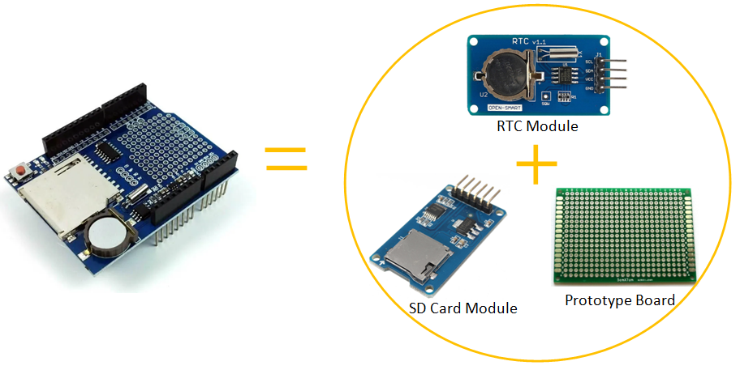

Figure 3- 3: Data logger parts [11]

The RTC module is used in timekeeping for the data logger. It includes an internal backup battery, allowing it to maintain accurate time even when the main power source is disconnected. This ensures precise logging of data with the exact time and date of measurements. The RTC module also enables time-triggered sampling, allowing for scheduled data sampling and synchronization with other stations, optimizing data transmission. It is connected to the Arduino Uno using the I2C communication protocol [12].

The SD Card Module provides non-volatile and high-capacity storage capabilities for the data logger. It offers a portable solution for storing large amounts of data. The module utilizes the Serial Peripheral Interface (SPI) communication to interface with the Arduino Uno. The sensors can be easily connected to the data logger through the prototype board [12].

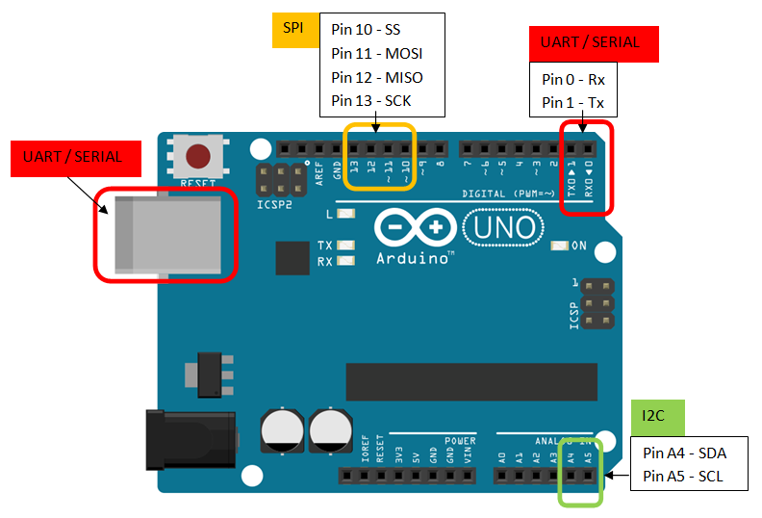

Figure 3- 4:pin Location of communication protocols [11]

### Tipping Bucket

The tipping bucket is a device used for measuring rainfall and is one of the most used methods available because it is known to produce accurate and reliable results [13].

The basic structure of a tipping bucket rain gauge consists of two buckets or containers placed on a pivot. When one bucket collects a certain amount of rainwater, the other bucket tilts and rotates to move into position to catch the next amount of rainwater. This tilting process gives the structure its name. When the bucket tilts, a switch or sensor (usually a reed switch or an optical sensor) is activated and records the number of times the bucket has tilted. Each peak usually corresponds to a certain amount of rain, such as 0.2 millimeters or 0.01 inches, depending on the device's measurement. Precipitation can be calculated by counting the number of falls over a period of time [14].

Another feature that can be obtained from the tipping bucket is by detecting these interruptions in the light, the optical sensor can accurately count each time the bucket tips, which allows us to capture the timing and duration of each tip. By measuring the time interval between consecutive tips, we can calculate the speed of rainfall, which provides valuable data for analyzing rainfall patterns and intensities.

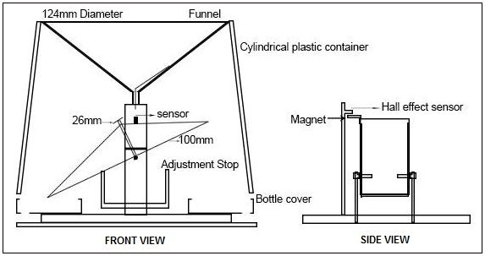

Figure 3- 5:Tipping buckets design [15]

### Anemometer

Anemometers are frequently used in weather stations as a tool for measuring wind direction and speed [16]. Usually, three or four little cups set on a horizontal axis make up a cup anemometer. The cups are set up so that the wind passes through the anemometer and is captured by the cups. The cups begin to revolve around the axis as they are propelled by the wind.

The wind speed and the rotation of the cups are inversely related. The cups revolve more quickly the quicker the wind blows. Using a sensor or magnet linked to the spinning axis and a coil or a Hall effect sensor nearby, this rotation is transformed into an electrical signal. The magnetic field changes or pulses are produced by each rotation of the cups and are counted and measured.

The number of rotations or pulses generated by the anemometer in a given time period can be used to calculate the wind speed. The anemometer may have a known calibration factor that relates the number of rotations to a specific wind speed range [17].

To calculate the wind speed using the anemometer, we utilize two equations. The first equation allows us to determine the voltage generated by the sensor. Since the Arduino has a 10-bit accuracy, we can calculate the size of each step in the analog-to-digital converter (ADC) by dividing the reference voltage ($Vref$) by 2 raised to the power of accuracy $(Step Size= \frac{Vref}{1024})$.

Multiplying this step size by the ADC reading obtained during the measurement process provides us with the voltage value resulting from the rotation of the wind sensor.

$Vout= \frac{Vref ×ADC}{1024}$ (1)

* $Vout$ represents the input voltage that is being measured by the analog-to-digital converter (ADC) (the output voltage from the anemometer).
* ADC is the digital value obtained from the ADC conversion process, which converts the analog input voltage into a digital value.
* $Vref$ is the reference voltage used by the ADC. In this case, it is set to 5 Volts.
* 1024 represents the total number of possible digital values that the ADC can produce.

If an anemometer is purchased, we need to refer to the datasheet of the wind sensor for the specific equation to convert the voltage into the corresponding wind speed value. This equation is provided by the sensor manufacturer and takes into account the sensor's characteristics and calibration.

But in our case, we will build the anemometer ourselves, so it is much cheaper than purchasing it, 3D printing can be used to facilitate the process, and using a flat center bearing can significantly reduce friction, which leads to a significant increase in accuracy.

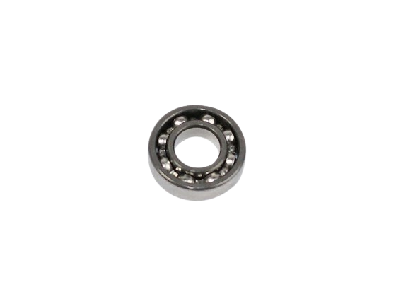

Figure 3- 6: Flat Bearing Center

The final part that will be used is the DC motor, which will be responsible for generating the voltage that will later be used to determine the wind speed.

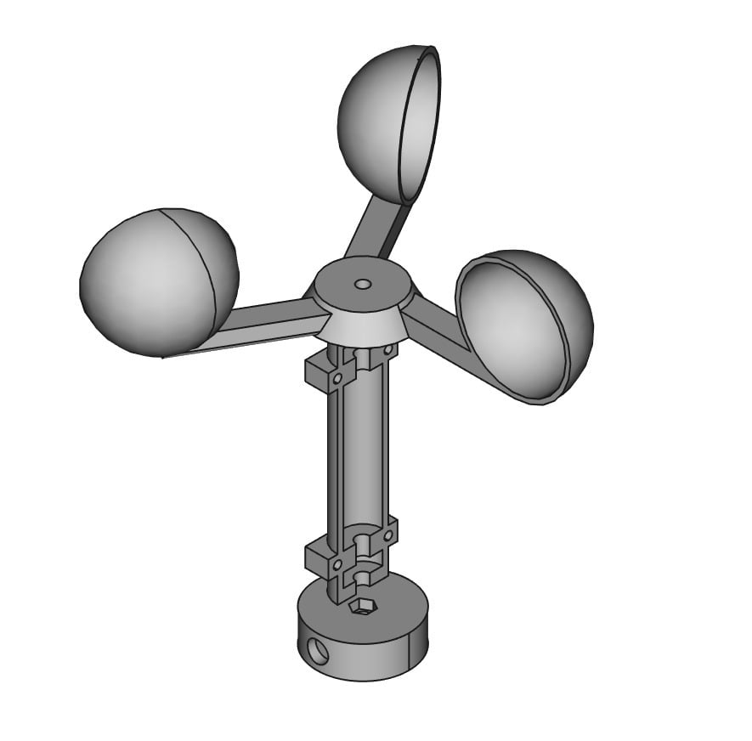

Figure 3- 7: Full image of the anemometer

### Wireless Transmission

To ensure complete coverage at the lowest possible cost, our project will utilize XBee modules for communication between the weather stations. These modules will be configured in a mesh topology, allowing good data transmission between the stations. The collected data will be sent to a station connected to the Internet using Wi-Fi, which will act as the main station. This method enables effective data transfer and remote access to the weather data that the stations have collected.

#### XBee S2C

The XBee S2C module is a wireless communication device that operates based on the IEEE 802.15.4 standard (**IEEE 802.15.4** is a technical standard which defines the operation of a low-rate wireless personal area network (LR-WPAN) [18]), specifically using the Zigbee protocol [19].

Zigbee is a low-power, low-data-rate wireless communication protocol designed for short-range applications. XBee modules can operate in Zigbee mode, enabling them to establish mesh networks and communicate with other Zigbee-compatible devices [19].

Mesh topology is a type of network topology in which all devices in the network are connected to one another [20] allowing multiple devices to communicate with each other, where data can be routed through intermediate nodes.

The topology of a Zigbee mesh network is typically a self-healing and self-configuring mesh, where devices can dynamically adjust and find new routes if a path becomes unavailable. This ensures reliable and flexible communication within the network [19].

Each XBee module can be a node so in order to establish communication within a Zigbee network we need to specify some characteristics (The channel, Personal Area Network ID (PAN ID), Addressing) and what type of node it is, there are three types of nodes, Coordinator, Router and End device [19]. The coordinator will serve as the base station, that will select the channel and the PAN ID, each mesh network must be formed by one, and only one, coordinator, on the other hand, the router is a node that will send, receive, and route information, unlike the coordinator the network can have multiple router devices. While the End device is a reduced version of a router that can send and receive information, but cannot route information but the main power of this node is that it can power itself down intermittently, saving energy by temporarily entering a non-responsive sleep mode. A network may have any number of end devices [19].

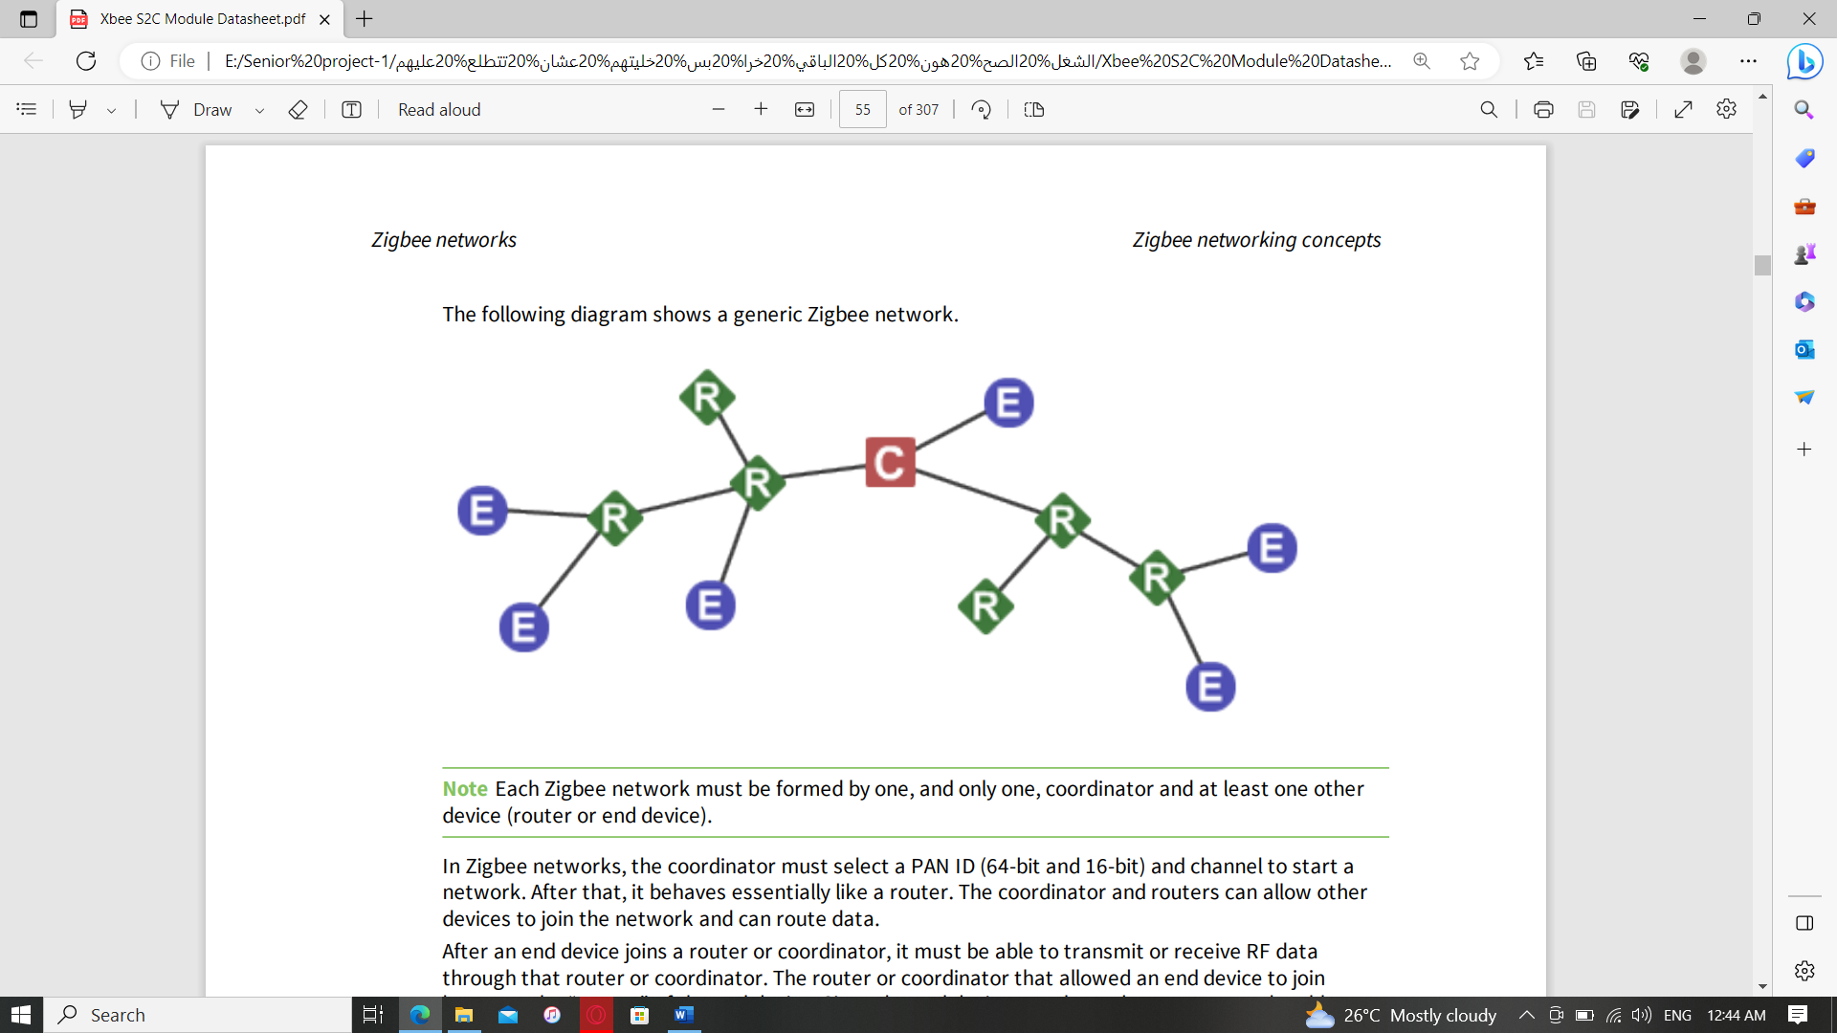

Figure 3- 8:generic Zigbee network [19]

The channel is the same frequency band that the nodes must share to establish the communication between each other.

The PAN ID serves as a unique identifier for the network. Devices with the same PAN ID can communicate with each other, while devices with different PAN IDs are isolated from one another [19].

Each node must have two addresses the source address (The current node address) and the destination address that will be the node that the data will be sent to, this address must be 16-bit and 64-bit address. A device receives a 16-bit address when it joins a Zigbee network. For this reason, the 16-bit address is also called the network address. The 16-bit address of 0x0000 is reserved for the coordinator. All other devices receive a randomly generated address from the router or coordinator device that allows the join. The 64-bit address is a device address which is unique to each physical device. It is sometimes also called the MAC address or the extended address and is assigned during the manufacturing process. All Zigbee transmissions are sent using the source and destination 16-bit addresses. The routing tables on Zigbee devices also use 16-bit addresses to determine how to route data packets through the network. However, since the 16-bit address is not static, it is not a reliable way to identify a device. To solve this problem, the 64-bit destination address is often included in data transmissions to guarantee data is delivered to the correct destination. The Zigbee stack can discover the 16-bit address, if unknown, before transmitting data to a remote [19].

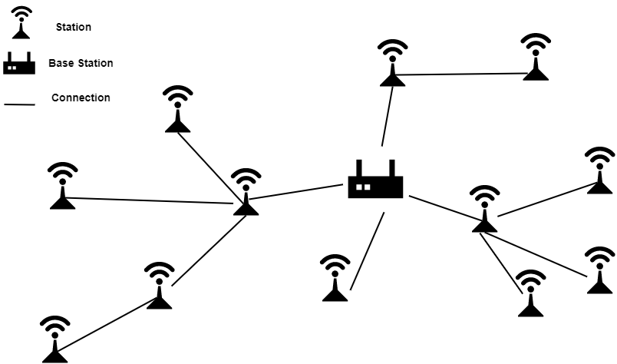

Figure 3- 9:Mesh Network of Stations

**For more information about the XBee S2C, you can see the datasheet in the appendices.**

#### Wi-Fi Transmutation

The Wi-Fi feature will be available only to the base station, and instead of getting the Arduino and the ESP8266 separately, we will use a component called Arduino Uno Wi-Fi, in which the Wi-Fi feature is built in.

The Arduino Uno Wi-Fi board is built around the ATmega328P microcontroller, which is the same microcontroller used in the Arduino Uno. However, it also includes an onboard ESP8266 module for Wi-Fi communication. This module allows the Arduino Uno Wi-Fi to connect to Wi-Fi networks, send and receive data over the internet, and interact with online services [21].

The ESP8266 module on the Arduino Uno Wi-Fi board uses the 802.11 Wi-Fi standard which allows it to connect to 2.4 GHz Wi-Fi networks, and it incorporates security measures such as WPA and WPA2 to ensure that the communication over Wi-Fi is secure and protected.

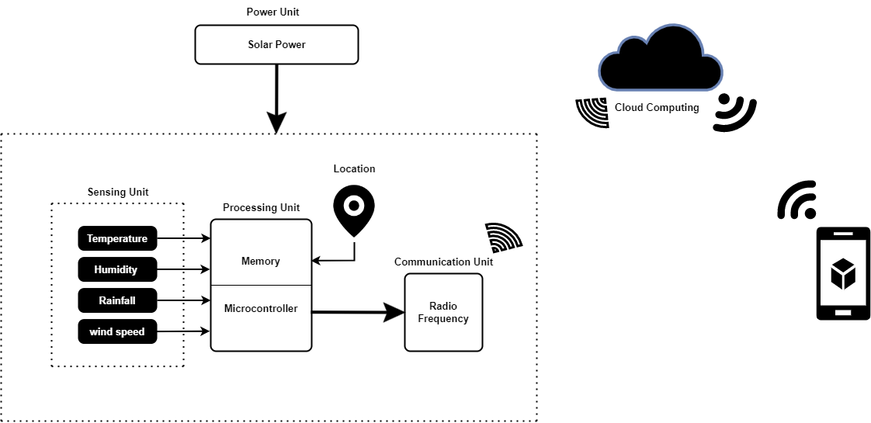

Figure 3- 10:Block Diagram for the Base Weather Station

### NEO-6M GPS receiver

The NEO-6M GPS unit is used to receive and process satellite signals to determine position, velocity, and time information. it contains a built-in 25 x 25 x 4 mm ceramic antenna that receives signals from several GPS satellites orbiting the Earth. These satellites continuously transmit signals containing time and position information [22]. The receiver processes these signals to extract data such as precise time, satellite positions, and satellite identification numbers. Using the data received from multiple satellites, the GPS receiver employs a technique called trilateration to calculate its precise position on Earth. Trilateration involves measuring the time it takes for signals to travel from satellites to the receiver and using the known positions of the satellites to determine the receiver's location. By precisely measuring the time it takes for the signals to travel, the receiver can determine the distances to multiple satellites. These distance measurements, combined with knowledge of the satellites' positions, enable the receiver to perform trilateration and calculate its accurate position in terms of latitude, longitude, and altitude [23] [24]. The data sheet for the NEO-6M GPS receiver is provided in the appendix for further information.

### Temperature Sensor

The weather station uses model DS18B20 as the temperature sensor. This sensor is capable of measuring temperatures from -55 to 125°C with a resolution of 9 to 12 bits. The DS18B20 sensor has three pins:

Two for power and one for data transmission. Temperature data is presented in a specific format. The figure below shows the data format consisting of a fixed point between bits 3 and 4. The first four bits represent the decimal value, followed by seven bits for integer data, and the remaining bits represent the positive or negative sign of the value. These values ​​are stored in two registers of 8 bits each, the microcontroller calculates these data and then sends them to the base station [25].

The DS18B20 temperature sensor enables the connection of multiple sensors to the same pin and uses a single wire for connection. This can be done using the unique 64-bit serial code programmed into each DS18B20, allowing easy sensor differentiation. The sensor also includes an alarm flag inside it, which will be raised when the value of temperature changes in the two registers. This enables the microcontroller to identify the specific sensor that has experienced a temperature change. Such functionality will be most valuable when expanding the coverage area of each controller, as it simplifies the process of monitoring and identifying temperature variations across a wide geographical range [25].

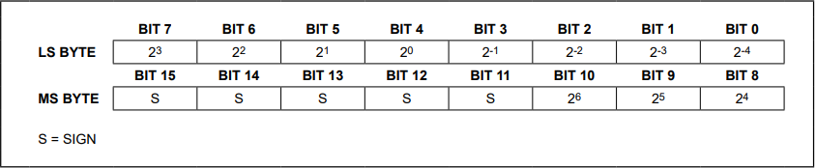

Figure 3- 11:Temperature register format [25]

### Humidity Sensor

The DHT-22 sensor, also known as the AM2302, is capable of measuring both humidity and temperature within a range of -40°C to 80°C for temperature and within a range of 0% to 100% RH for the humidity.

The resolution of this sensor can be up to 0.1°C for temperature and 0.1% for humidity, it can be easily interfaced with microcontrollers, that comes for many reasons that are it has a low power consumption, single-wire communication protocol, and digital output producing, making it suitable for long-term monitoring applications [26]. The term digital output means that we can connect it to a digital pin without the need for ADC conversion.

### Solar Power System

The power unit for the weather station includes a 10W solar panel, a battery protection board, and a storage cell. The purpose of the battery protection board is to regulate the voltage output from the solar panel and prevent overcharging of the storage cell. During the day, the solar panel charges the storage cell, ensuring that the sensor node remains operational even during partially cloudy weather and at night. To estimate the node's operating life, current consumption measurements were taken.

The power calculations can be determined based on the current consumption of the components. (These data are taken from the data sheets)

* Arduino: 42mA
* Data Logger: 80mA
* Temperature Sensor: 3mA
* GPS: 45mA
* XBee S2C: 45mA
* Wind Speed Sensor: 16mA
* Rainfall Sensor: 0.115mA

Total power consumption =

42mA + 80mA + 3mA + 45mA + 45mA + 16mA + 0.115mA = 231.115 mA  
The battery capacity is 5400, meaning that the unit can operate for 22.5 hours, and the duration can be increased by increasing the capacity. If the Arduino is placed in sleep mode, which saves energy to a large extent, the duration can be doubled.

### Stations Placement and Data Transmission

Determining the distance between each weather station and the frequency of data transmission is a flexible aspect of the project that depends on various factors. These factors are influenced by the surrounding environment and the specific requirements of the user.

The distance between weather stations can be determined based on the desired coverage area to collect weather data. It is important to strategically place stations to ensure sufficient coverage while considering all factors affecting stations distribution. On the other hand, the frequency of data transmission from the stations can be customized to the specific needs of the user such as the level of details required. However, based on some research, three minutes interval between each measurement process is sufficient to measure weather change accurately [27], and the data can be stored for a week, and then all data is erased from the database, but the user can store whatever data he wants in the form of reports. Therefore, these are the default settings of the system, which can be modified at the request of the user

By taking these factors into account and adapting the project to the unique circumstances, the user can effectively design a weather monitoring system that meets their needs and maximizes the benefits of the collected data.

### System Application

This application will be used for visualizing and displaying the data collected from weather stations. while Various APIs will be integrated to improve user experience by providing various ways to display data.

One of the application's main features is a dashboard page that provides the user with the latest weather data received from the mobile stations. This dashboard allows users to access the latest weather conditions quickly.

The application will integrate with APIs such as Google Maps, ThingSpeak, and OpenWeatherMap to provide suitable representations of weather data. You can visually check the weather conditions in various regions by displaying the station locations on the map. Additionally, integration with these APIs enables the creation of heatmaps that highlight changes in weather factors.

The application will also provide another representation in the form of charts, these charts allow users to analyze and compare various weather parameters. Graphs help users identify patterns, track historical trends, and gain a better understanding of weather conditions over time.

* 1. Design Specifications, Standards, and Constraints

### Specifications

After building the stations, they are distributed based on factors determined by the surrounding environment and the user, and then adjust the network settings for the data transfer process between them. This data is directed to the base station, which is the only one connected to the Internet, with the presence of a data logger that guarantees a large storage capacity and the ability to divide time periods. The weather data collected from the modules is transmitted to a database hosted on a cloud service.

The application establishes a connection to the cloud service, allowing users to authenticate and access their specific data. The application`s user interface is designed to enable users to easily navigate through different sections and get the weather information they need.

### Standards

**IEEE 802.15.4:** is a technical standard which defines the operation of a low-rate wireless personal area network (LR-WPAN) [18]

**802.11a/b/g Wi-Fi standard:** is part of the IEEE 802 set of local area network technical standards, and specifies the set of media access control and physical layer protocols for implementing wireless local area network computer communication [28].

### Constraints

1. The range provided by the XBee is one km as a maximum in open places.
2. The battery capacity must be large so that it stays on all night and also takes into account the lack of sun at some times during the day at least 2700mA so it can last for 12 hours.
3. The stations must withstand various weather factors that can be harsh (This can be done by designing a container that can be fixed to the ground).
4. The main station must have an Internet connection to ensure data transmission.
5. The user must be connected to the Internet to access the latest data from the stations.
   1. Design Alternatives

### The microcontroller

In terms of the microcontroller, more than one alternative can be used, each one has its own characteristics and disadvantages. An Arduino Mega can be used due to the large number of pins and its ability to supply a higher current than the Arduino Uno, which allows us to add many sensors that monitor the surrounding environment, and this leads to increased exposure to the environment, which gives more accurate results and bring us closer to understanding the surrounding environment but on the other hand the cost and the power consumption will increase dramatically.

Another alternative of using a powerful microcontroller that can collect and processes the data, Instead, a simpler microcontroller can be used to collect the data and send it to the main station, which must be strong enough to process all the data, this alternative will reduce the cost in a very good way, but it will put a huge load on Network and the main station, this huge pressure of data will greatly reduce the lifespan of the network.

### The Communication Module.

The HC-12 can serve as an alternative to the XBee module for data exchange, due to its low energy consumption, long-range that extends up to 1 km, and it is low cost as well. Still, the problem here is establishing a network that is efficient for data transmission because it is not manufactured to route data, so in order to create a network using this module will require a lot of time and effort and will not be as good as XBee, but it can be taken into consideration if the project continues to develop.

### Data-sharing

Satellite communication can be used to improve data-sharing capabilities when internet access is nonexistent. Data transfer to and from Earth can be facilitated by satellites, thereby getting beyond the restrictions of networks on Earth [29].

* 1. System Analysis and Optimization

### Hardware and software integration

#### Temperature Sensor (DS18B20)

This sensor can work in two modes, the normal mode or the parasite mode, in the normal mode the sensor takes power from an external power line, and in the parasitic mode it can take power from the data reading line, this will help us how to wire the sensor [25].

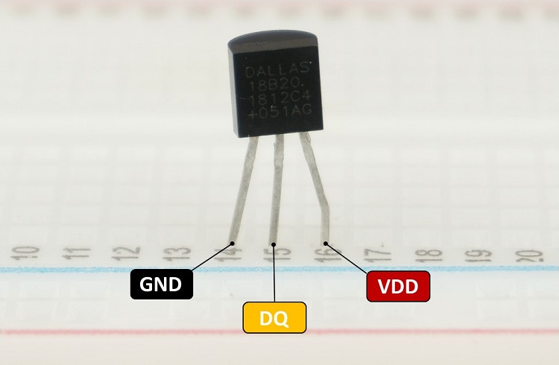

Figure 3- 12:DS18B20 pins [30]

The following table states that each bin of the sensor must be connected:

|  |  |
| --- | --- |
| **DS18B20** | **Arduino** |
| GND | GND |
| DQ | Any digital pin (with 4.7k Ohm pull-up resistor) |
| VDD | 5V (normal mode) or GND (parasite mode) |

Table 3- 1: DS18B20 to the Arduino [30]

Since this sensor reads and converts the data on its own (Built-in ADC), all that is required is to read the temperature stored in the two registers. The process is illustrated in the diagram below.

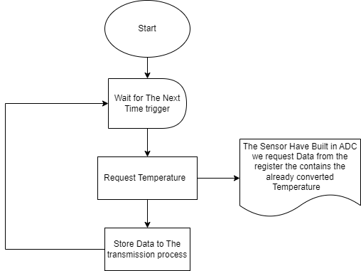

Figure 3- 13: DS18B20 Flowchart

#### Humidity Sensor (DHT-22)

This sensor presents both humidity and temperature directly in a digital format, meaning that it has a built-in ADC. Which makes the process of connecting it with Arduino an easy process and does not require much.

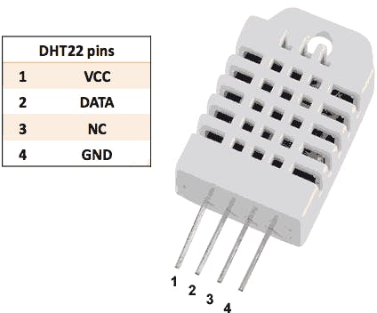

Figure 3- 14: DHT-22 pins [31]

The following diagram shows the process of reading both the temperature and humidity of this sensor

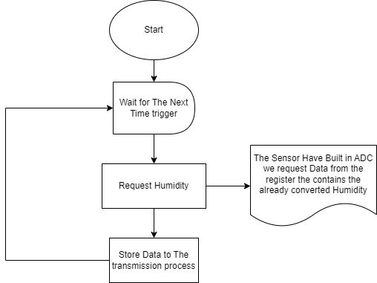

Figure 3- 15:Humidity Flowchart

#### Wind Speed Sensor

Unlike the temperature and the humidity sensors mentioned earlier, the Anemometer does not have a built-in ADC, so in order to measure wind speed we need at first to obtain the ADC reading from the analog input pin to get the voltage value (Vout) from the anemometer.

Then we must use equation (1) that is mentioned in section (3.1.3) to calculate the voltage (Vout) from the ADC reading.

To build a wind sensor, it's essential to establish a reference relationship between the wind speed and the corresponding voltage output from the sensor. This reference relationship will allow us to calibrate the sensor and accurately determine wind speed based on voltage readings.

If the relationship between wind speed and voltage output is linear, it simplifies the calibration process. We need to collect data points at different wind speeds and measure the corresponding voltage outputs from the sensor. With these data points, we can perform linear regression analysis to find the slope of the linear function (which represents the sensitivity of the sensor). Once you have the slope, we can use it to convert voltage readings to wind speed using the equation of a straight line:

**Wind Speed = Slope × Voltage + Intercept**

**Where the intercept might be the voltage output at zero wind speed.**

If the relationship is non-linear, we need to find the equation that best fits the data. This could involve polynomial functions, exponential functions, or other non-linear models. Tools like curve fitting algorithms or software packages like MATLAB can be useful in determining the equation that accurately represents the relationship between wind speed and voltage output.

Once we have the equation for the non-linear function, we can use it to calculate wind speed from voltage readings. This may involve iterative methods or numerical techniques to solve the equation for wind speed given a specific voltage.

Regardless of whether the function is linear or non-linear, it's crucial to gather sufficient data points across a range of wind speeds to ensure accurate calibration.

#### Rain Fall Sensor

Measuring rainfall faces two main challenges: the infrequent occurrence of rain and the need for efficient data collection without interrupting other weather parameter readings, as an example when it is raining we can't wait every three minutes or more to remeasure and at the same time we can't stay reading the rainfall amount because it may take too much time affecting other weather parameters, To address these issues, we employ a solution that utilizes an interrupt pin wired to the rainfall sensor.

When raindrops fill up a bucket and tip, the interrupt pin is triggered, allowing us to increment a variable. Each bucket tip represents a specific volume of rainfall. By multiplying the variable by the bucket size, we determine the total rainfall accurately.

The advantage of using interrupts is that we no longer need to continuously monitor the sensor every few minutes, conserving time and resources. Additionally, we reset the rainfall variable at the end of each day to measure the total rainfall for that specific day.

This approach ensures that we efficiently capture rainfall data while focusing on other weather parameters. It strikes a balance between data accuracy and minimal disturbance during rainfall measurements. By considering daily accumulations, we obtain a comprehensive overview of the rainfall patterns over time.

The opto sensor consists of two components infrared led, and phototransistor, each one has two pins [32], the figure below shows the components in which both input and the Vcc are connected to 5V.

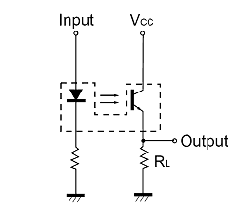

Figure 3- 16: Opto sensor Components [32]

The infrared LED will continuously emit light towards the phototransistor, and when the bucket is full and tips over, an object will pass between the infrared LED and the phototransistor, causing an interruption in the light beam, his interruption will trigger in the Arduino Uno this indicates that the interrupt condition will become valid at the low value the diagram below.

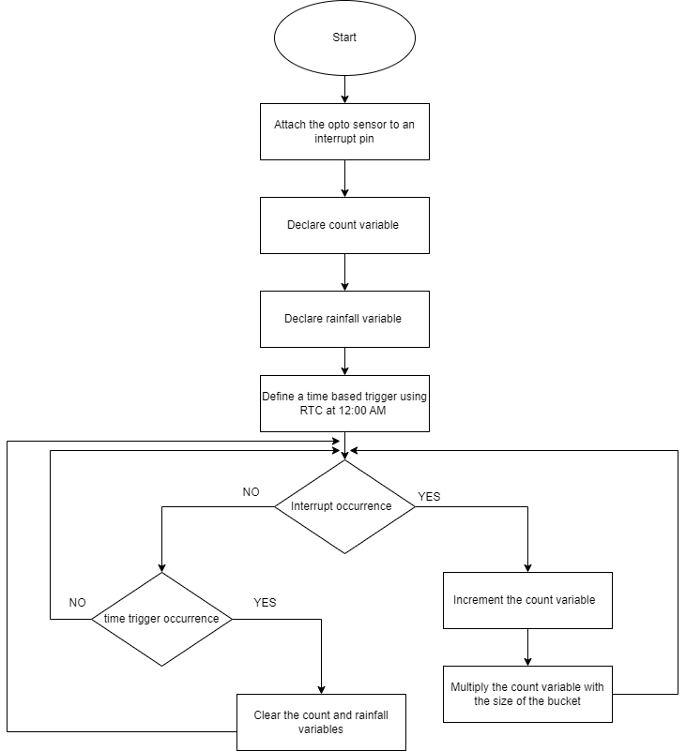

Figure 3- 17:Rainfall Flowchart

#### System Flowchart

Since we aim to establish a network of wireless sensor modules using XBee devices for data transmission between Arduinos. The network will consist of multiple modules, with each network having one main module designated as the coordinator. Other modules will be added as Routers or End Devices based on their roles within the network.

The main module (Coordinator) will be connected to the internet and serve as the gateway for data to be sent to a cloud-based database. Data collection involves measuring various environmental factors such as temperature, humidity, wind speed, and rainfall. Each module in the network, whether a Router or End Device, will be equipped with sensors to collect this data at regular intervals (As a default it will be 3 minutes).

To ensure reliable data transmission and prevent data loss, we plan to implement a data acknowledgment protocol. When a module sends data to the next module, it will expect an acknowledgment in return to confirm that the data was successfully received. If an acknowledgment is not received within a specified time frame, the module will re-transmit the data to avoid any loss.

To handle situations where a module cannot send data due to network issues or other factors, The Data Logger will use an SD card to store collected data in a queue. This way, even if a module experiences transmission difficulties, the data will be saved for later re-transmission when the network is available

Data duplication is another concern that we will address. To prevent duplicate data on the receiver side, we know that the day will be divided into time intervals, a table with a unique identifier that will be the time and MAC address of the module. Upon receiving the data, the receiving module will acknowledge by re-sending the identifier to the sender, and set a data-ready mark in a partition table if a data is resented from the sender the data will be discarded. On the sender side, we can just delete the sent data from the queue after receiving the acknowledgment to avoid duplicated transmutations in the following charts.

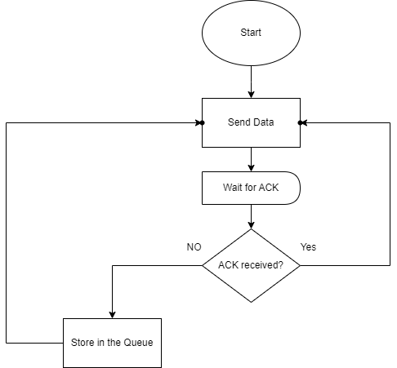

Figure 3- 18:Sender Side flowchart

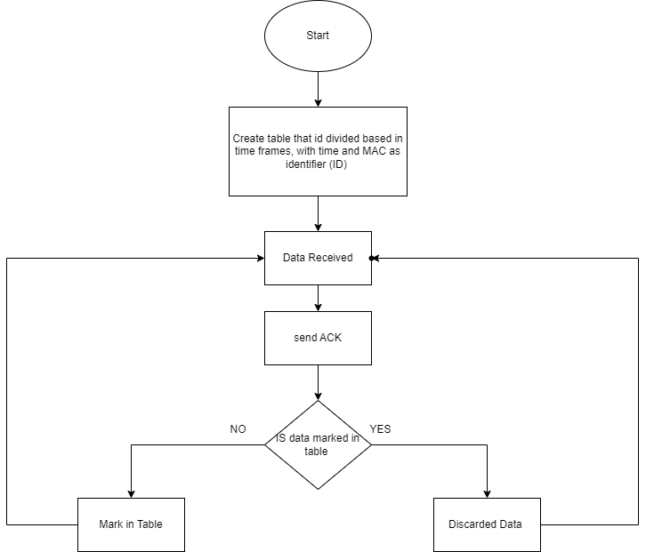

Figure 3- 19:Receiver Side flowchart

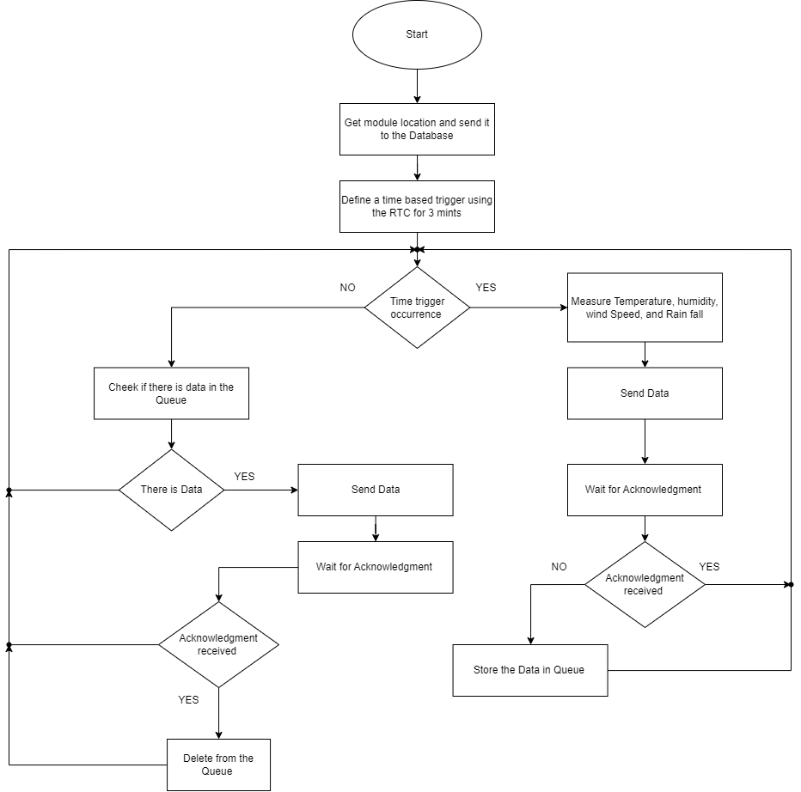

Figure 3- 20: System Flowchart

### System application

In this section, we will explain the features (functional), and nonfunctional requirements that the application will provide.

#### Product Functions

These are the major features the application performs described in high-level sentences:

1. Dashboard:

The home page displays the current weather information from a station chosen by the user.

1. Map-based interface:

The UI (user interface) must include a map showing the exact location of the distributed modules.

1. Information visualization:

Various forms of displaying the data collected from the stations can be represented by line graphs, bar charts, scatter charts, and heat maps.

1. Data analysis and reports:

Tools for generating comprehensive weather reports, including summary statistics, notable events, and trends over time.

1. Alerts and Notifications:

Inform users about significant weather events or anomalies.

#### System Features (Functional Requirements Detailed)

This section will explain each feature, providing a brief description of the feature, and other software capabilities that must be present in order for the feature to work or perform the right functionality.

#### Dashboard

The dashboard should have an easy-to-use interface that displays weather conditions, such as temperature, wind speed, and precipitation, collected by the distributed units. These data should be displayed in visual representations, such as graphs or charts, to present the data in an understandable format.

The dashboard will also display part of the map for the area where the readings are displayed.

In order to present the data in different formats the application will use ThingSpeak API to display charts and graphs. Another API called OpenWeatherMap is used to display a heatmap for a weather condition the user can choose like temperature wind speed or humidity.

#### Map-based interface

The map interface should display the location of the distributed units in the form of markers or symbols that stand for them on the map.

This Feature will use the GPS service to mark the location of the mobile units, additionally, if possible, we will add a feature, that enables the user to select a mobile unit from the map, and it will show him the weather information about this mobile unit.

#### Information visualization

This feature shall allow the user to view the current weather information and the historical data that is collected from a weather station, that the user chooses, the data also can be presented in charts, graphs, or heatmaps that show the change of the weather condition with time.

#### Information visualization

The user interface should supply features for analyzing the data and generating reports based on the weather data collected.

The user interface should supply tools for generating comprehensive weather reports, including summary statistics, notable events, and trends over time.

Additionally, the application will provide a report that indicates the state of the mobile unit, if it sends data or not, is connected or not, and if any sensor sends any invalid data.

#### Alerts and Notifications

The UI should have an alert/notification system to inform users about significant weather events or anomalies.

Users should be able to configure thresholds or conditions for generating alerts and notifications. When a predefined threshold or condition is met, the system should trigger an alert or notification.

The UI should display the alert or notification message with specific event details, allowing users to act appropriately.

### ER Digram

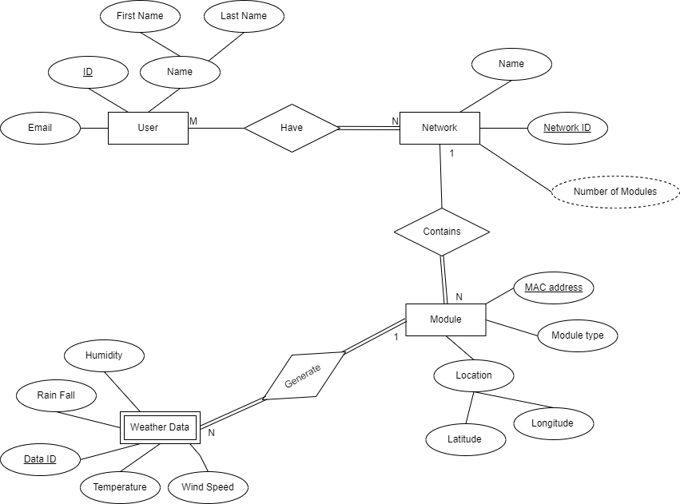

Figure 3- 21:ER Diagram

### Schema

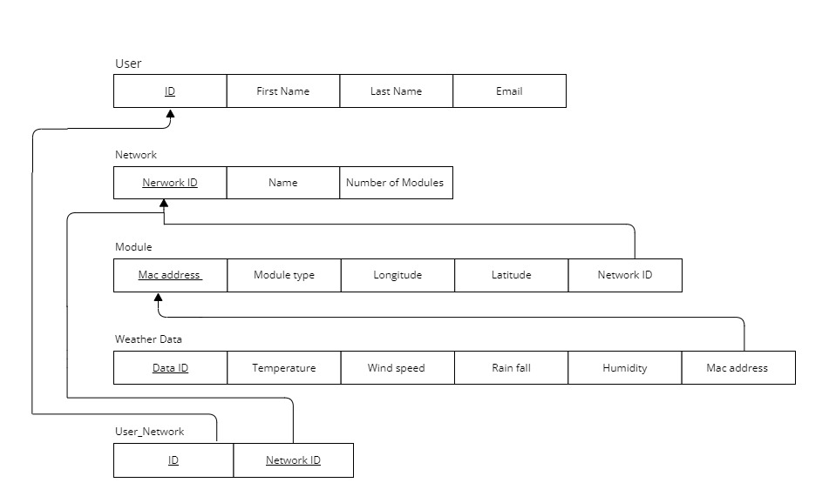

Figure 3- 22: Project Schema

* 1. Simulation and/or Experimental Test

In this section, we will talk about the progress process in building the project and talk about the process of adding each piece and programming it in the project completely, in addition to all the functions that the project fully provides and some of the challenges that we faced during the construction of this project.

### Hardware

#### Budling the Network

Central to our project is the establishment of a robust network, utilizing a mesh topology, At the heart of this network architecture lies the XBee S2C module, The choice of the XBee S2C module stems from its intrinsic compatibility with the Zigbee protocol, renowned for its prowess in facilitating mesh networks. Leveraging this protocol empowers our project with the flexibility and scalability necessary for dynamic communication environments.

One of the standout features of the XBee S2C module is its inherent configurability, allowing for versatile deployment scenarios. By configuring the XBee modules to operate as routers, we augment the network's capacity for data routing, enhancing it, and expanding its reach. This capability not only amplifies the network's robustness but also imbues it with the flexibility to adapt to evolving network demands and topological challenges.

In order to set up any xbee, it must be connected to a computer first, and here we begin with the first problem we faced. In order to connect the xbee to a computer, another component is required called the USB XBEE Adapter. However, its price is a little high and the situation the country is going through does not allow it to be ordered from abroad. Through diligent research, we discovered an alternative solution: leveraging the Arduino Uno as a makeshift USB XBee Adapter. To facilitate this adaptation, it was imperative to prevent the Arduino Uno from loading its bootloader. This was achieved by establishing a connection between the Reset pin and ground (GND), thereby ensuring the Uno remained in a state receptive to XBee communication.

Subsequently, the XBee was connected to the Arduino Uno as depicted in the accompanying figure:

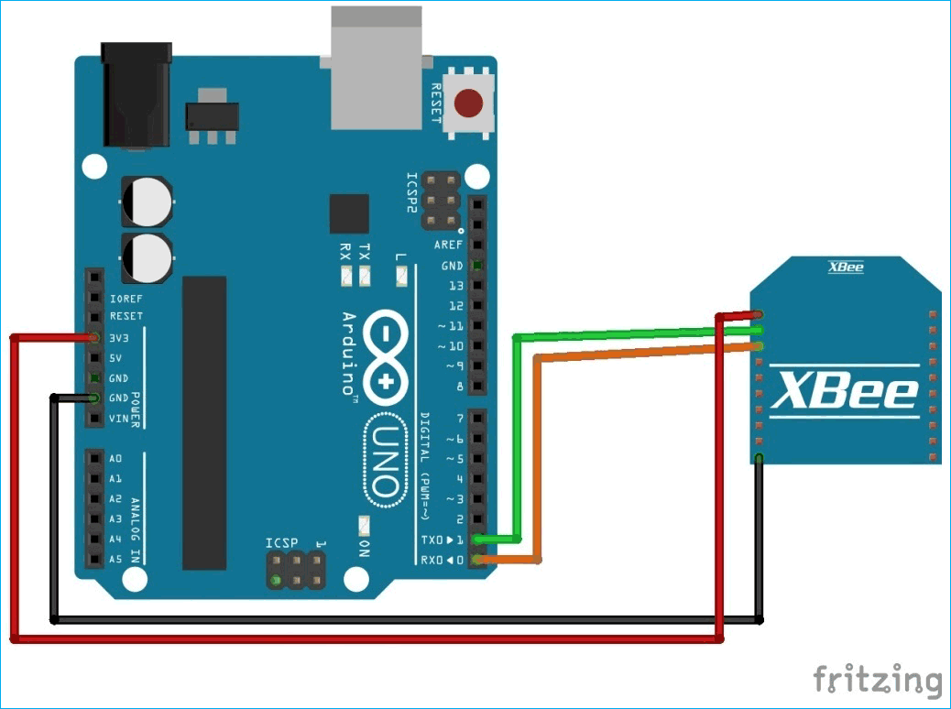

Figure 3- 23: Circuit-Diagram-for-XBee-Module-Interfacing-with-Arduino [33]

To establish the network hierarchy, a coordinator must be designated at the network's forefront. This is accomplished by selecting one of the XBee units and configuring it as the coordinator using the XCTU program. Additionally, a PAN ID (Personal Area Network Identifier) is assigned to the network, ensuring uniformity across all units within the same network.

The designated coordinator unit must also activate the coordinator option to assume its role effectively. Finally, enabling API2 mode is essential. It's noteworthy that XBee operates in two modes: AT mode, where the xbee sends any data present on its serial port directly, and API mode, where data is encapsulated into packets for transmission at the developer's discretion.

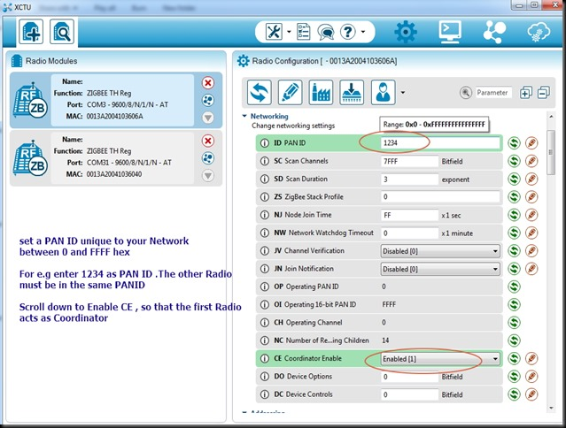

Figure 3- 24: XCTU interface for Coordinator configuration

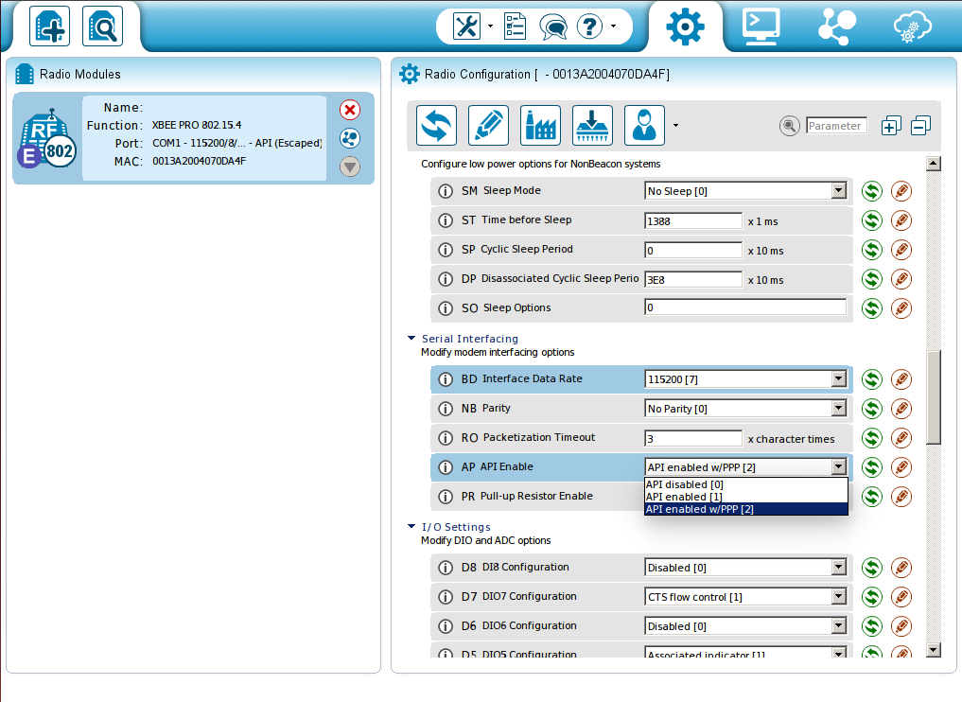

Figure 3- 25: Enabling API mode for the Xbee

Any other xbee will be configured to be a router. The only difference between a router and a coordinator is that instead of activating the coordinator option, the join network option will be activated.

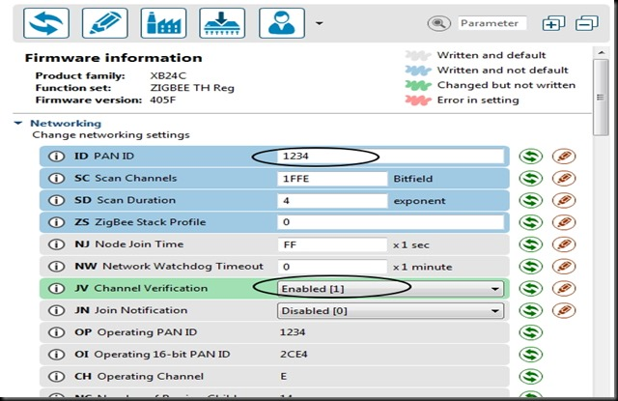

Figure 3- 26:Xbee Configuration as a Router

Of course, there are ways to test whether the Xbees communicate with each other using the XCTU program, but they will not be discussed here. You can use the Internet or the official website of XCTU for more information.

With the preliminary setup complete, the next phase involves reconfiguring the XBee's connection, necessitating a shift in focus back to the Arduino Uno. The previous reset-to-ground connection can be reverted to its original state, as the Uno will now take center stage for further operations.

While the previous connection setup can be maintained, it becomes cumbersome due to the Uno's single hardware serial interface, which is utilized for code uploading. To overcome this limitation, software serial communication is employed on pins eight and nine. This approach ensures uninterrupted code uploading without the need to disconnect hardware serial connections.

Refer to the figure below for a visual representation of the updated connection method.

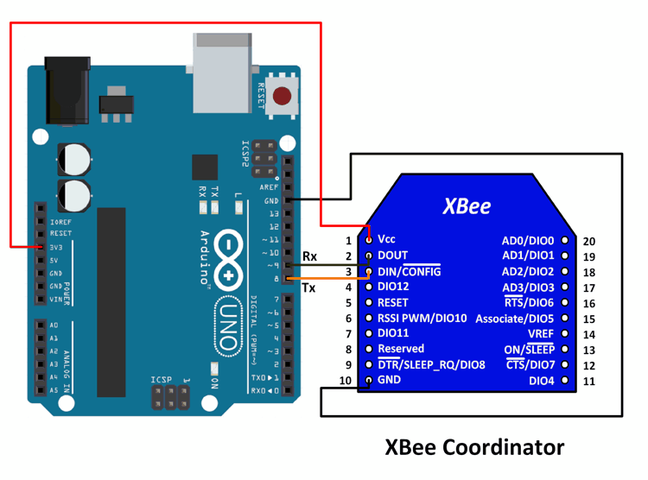

Figure 3- 27: New Xbee to Arduino connection [34]

As previously mentioned, all sensor readings will be transmitted to the main unit, acting as the coordinator, which is also connected to the internet. To streamline the transmission process, the main unit is assigned an address consisting of zeros.

Transmission is structured in packet format, beginning with a start delimiter (0x7E) and concluding with a checksum to ensure data integrity. Each packet comprises several bytes, starting with the length of the packet, followed by the packet type (given that there will be several types of packets that will be sent), sender's address, receiver's address, options parameters, data payload, and finally, the checksum.

While manufacturers often provide packet structures in their datasheets, custom arrangements can also be devised to suit specific project requirements.

This is like the most basic explanation on how sending the data will be handled, you can refer to the official site of the ZigBee protocol to see more about how the packets are organized.

Fortunately, there is a library for working with Xbee called xbee-arduino by Andrew Rapp, that can help sending and receiving buckets.

With this, the first step is ready, we move to the second step section, which is the sensors

#### Sensors

##### DHT22

This sensor provides us with a humidity reading. It will be connected to any pin of our choice. It will not make any difference. In our case, we used pin number four. A special library for this family of sensors will be used called DHT sensor library by Adafruit, which simply will connect the type of sensor used in our case, DHT22, to the pin number to which the sensor is connected, the humidity reading is done with one line. The reading is only requested since the sensor gives the ready reading.

##### DS18B20

The sensor we're utilizing provides temperature readings and will be connected to pin No. 5. To interface with it, we'll utilize two libraries: 'oneWire' and 'DallasTemperature'. The 'oneWire' library facilitates communication using the one-wire protocol, enabling us to connect multiple sensors to the same pin and selectively read data from each sensor. The 'DallasTemperature' library, on the other hand, provides a straightforward method for obtaining sensor readings.

When it comes time to read the data, we'll simply request the sensor reading, allowing us to retrieve the temperature information from the connected sensor.

##### Anemometer

After assembling all the specialized components, including the installation of the central flat bearing and connecting the DC motor, the next step was to calibrate the wind sensor using a reference source. However, due to the unavailability of a suitable reference, an alternative method was employed.

The wind sensor was calibrated by measuring the airflow generated by a hairdryer operating at four different speeds. Using the wind sensor, we were able to determine the corresponding airflow velocity for each speed setting of the hairdryer

##### Rainfall sensor

Measuring rainfall accurately poses a challenge despite its simplicity in concept. Typically, rainfall is quantified by measuring the height of collected water. One straightforward method involves placing a container outdoors and recording the water's height, ensuring the container maintains a consistent diameter throughout its height. It does not matter whatever the diameter of the container, but the larger it is, the greater the accuracy.

However, using this method in our project is impractical, because a person cannot always go and measure the height of the water at each unit and then empty the water, and here comes the role of the tipping bucket method, this method involves counting the number of times a bucket tips, facilitated by an opto sensor. Subsequently, we utilize a specific equation to calculate the amount of rainfall based on the recorded tipping frequency.

$$RainFall Amount= \frac{No. of tips *Size of bucket}{Area of the funnel}$$

Given the infrequency of rainfall for most of the year, continuously monitoring the sensor for changes consumes considerable energy. Additionally, rainfall events are often sudden, and the execution of other tasks in the code may interfere with accurate counting of rainfall. To address these challenges, Interrupts play a crucial role.

Interrupts allow the Arduino board to prioritize counting rain events as soon as they occur. By directly counting raindrops in the tipping bucket via Interrupts, we can calculate rainfall in real-time and transmit the data efficiently. This approach not only enhances accuracy but also enables us to determine rainfall intensity based on the rate of precipitation change.

Arduino boards typically offer dedicated pins for Interrupts, with pins two and three commonly designated for this purpose.

In this way, the number of tilts was calculated, we start with the known area of the funnel, which is a circle with a radius of 3.75 cm. Using the equation for the area of a circle, we determine the funnel area to be approximately 44.18 cm2. However, determining the volume per tilt requires a practical approach rather than mathematical calculations.

We achieved this by pouring a known quantity of water into the sensor and observing the number of tilts it produced. In our experiment, we poured 20 mm of water, resulting in 12 tilts. Dividing the volume of water by the number of tilts yields approximately 1.6667, representing the volume per tilt of the bucket.

With all the necessary parameters known, we're equipped to accurately measure rainfall using the tipping bucket method.

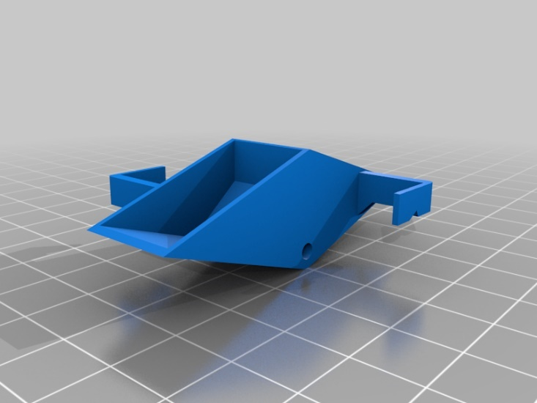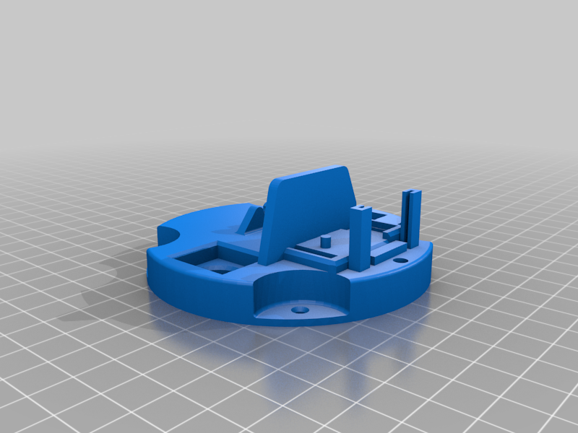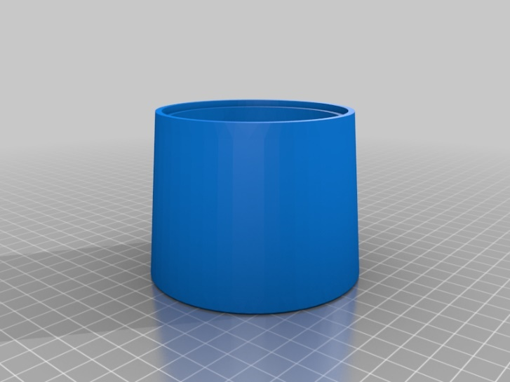

Figure 3- 28: Buckets and Base [35]

Figure 3- 29: Case [35]

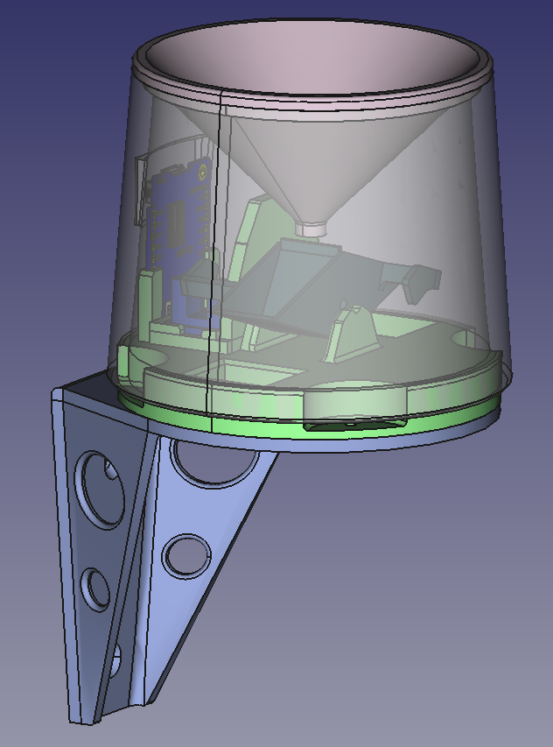

Figure 3- 30: Full Sensor [35]

#### All together

Now that we have clarified the requirements for each sensor to function properly, let's proceed with building the entire system together. Our project entails a network comprising two or more units. To kick things off, we've prepared three units.

The first unit is equipped with all the necessary sensors, as previously detailed, and housed in a specialized case that accommodates these sensors along with two batteries connected in series. Each battery has a voltage of 3.7, resulting in a total of 7.4 volts, ensuring efficient operation of the Arduino and sensors. Additionally, we incorporate a solar panel, albeit one providing only 5 volts. To address this voltage discrepancy, we require a regulator to boost the voltage for efficient battery charging. It's crucial to disconnect the battery from charging once it's full to prevent damage to the batteries or the unit.

Next in line is the main unit, also known as the coordinator. This unit consists only of the Arduino Uno Wi-Fi board and the Xbee. So, how do we kickstart our network? It's a straightforward process. We'll commence by initiating the coordinator unit, which is the head of the network, it will then enter a standby mode, awaiting any incoming packets from other units. Subsequently, we'll proceed to integrate additional units into the network. When a non-coordinator unit, such as the first unit containing all the sensors, is activated, its Xbee module will automatically scan for available networks to join. Upon successful integration, the unit will send a packet containing the readings of the sensors, this packet is useful for telling the main unit that it is present. In turn, the main unit upon receiving these packets, will record the address of each unit and proceed to decode the incoming data. and send it to the database on the Internet, the first unit will commence transmitting sensor readings at predetermined intervals, with a time interval typically set to 10 seconds, although it can be adjusted based on user preferences.

The primary responsibilities of the main unit encompass two critical tasks: incessantly monitoring for incoming data from the units and issuing commands to the units based on user inputs. Further details regarding the nature of user inputs and the corresponding commands dispatched by the main unit will be elucidated in the next section.

Now, let's discuss the third unit, a pivotal addition highlighting our network's dynamic scalability. This unit serves a dual purpose: ensuring continuous data transmission between the first unit and the main unit even if their direct connection is disrupted, and extending the communication range between them. Acting as a conduit for data transfer, it plays a crucial role in maintaining seamless communication within the network.

Moreover, the third unit serves as a demonstration of the main unit's ability to discern between different units and route their data individually. This capability underscores the versatility and intelligence of our network infrastructure, showcasing its adaptability to diverse scenarios and requirements.

It should be noted that the main unit uses a protocol called MQTT (Message Queuing Telemetry Transport) to send data to the internet database. This protocol provides several advantages. MQTT is lightweight and efficient, making it ideal for resource-constrained Arduino projects. Compared to HTTP (Hypertext Transfer Protocol) that is a heavier protocol primarily designed for human-readable web browsing, which may be less efficient for IoT (Internet of Things) applications, MQTT consumes less bandwidth due to its publish-subscribe messaging pattern, enabling devices to subscribe to specific topics and receive relevant messages only. Additionally, MQTT supports asynchronous communication, ensuring devices can operate autonomously and respond quickly to events. It offers reliable message delivery, scalability for thousands of connected devices, and potential for extending battery life in battery-powered devices. Overall, MQTT is well-suited for IoT applications, offering efficiency, reliability, and scalability for Arduino projects.

### Other features the project provide

we'll discuss system response scenarios and how the it will act to each. We've endeavored to anticipate and address the majority of potential cases. presenting our findings in sub-sections format for clarity and completeness.

#### Handling Connectivity Issues

In the event of connectivity difficulties with the Internet or MQTT protocol, or a sudden loss of connectivity, the main unit will broadcast a message to all connected units, instructing them to halt transmission, and store the data locally until the connection to the Internet or the MQTT is restored. Whenever the other units receive a message to stop, it will do its job normally, but in this case, it will encapsulate the readings in the form of a packet and then store it. To be ready for transmission whenever the main unit regains its internet connection. Upon successful reconnection, the main unit will send out another message to all units, signaling them to resume transmission.

#### Integration of New Units

When a new unit joins the network and sends an informational message, the main unit will assess the current transmission status. If units are instructed not to transmit due to a connectivity issue, the main unit will record the address of the newly added unit and send a specific message instructing it not to send data but to store it locally. Upon reconnection, the main unit will notify all units to start the transmission process again.

#### Handling Message Acknowledgment

In cases where a unit sends a message but fails to receive acknowledgment, it autonomously stores the message locally. The unit periodically checks its local storage and attempts to resend the message until acknowledgment is received, with the frequency of attempts adjustable to user preferences.

#### Retransmission Process

If the main unit reconnects to the Internet or to the MQTT protocol, it will broadcast a message to restart the transmission process. Upon receiving the message from the main unit, each unit resumes its regular operations and each unit will check local storage for pending data every two seconds and transmit stored data until acknowledgment of successful transmission is received.

#### Monitoring Connected Units

Utilizing the MQTT protocol, users can monitor the status of connected units. By subscribing to relevant topics, users can query the main unit to confirm the presence of each unit within the network. Through subscription, the user can send a message to the main unit using various methods such as a button, input text, or a variable. Whenever there is a change in the subscribed value or state, it is relayed directly to the Arduino. In our case, let's consider a button press triggers this change. Once pressed, the main unit will dispatch a message to all units, confirming their presence within the network. The main unit then awaits confirmation from each unit regarding their presence. Subsequently, the main unit relays the status of each unit to the database.

#### Environmental Control Based on Sensor Readings

Selecting specific sensors and defining threshold values, users can automate actions such as activating motors in response to environmental conditions. For instance, suppose the user opts to control a DC motor in response to wind speed fluctuations. Using the subscription feature, the user selects a threshold wind speed value. When the actual wind speed surpasses this threshold, the motor activates automatically. Conversely, when the wind speed decreases below the specified threshold, the motor stops. Moreover, the user retains the flexibility to adjust the wind speed threshold at their convenience. Additionally, our system accommodates the addition of up to 17 different sensors, enabling users to customize control parameters for various environmental conditions.

#### Precision Control Over Surroundings

Through the subscription feature, users can exercise fine-grained control over surrounding environments. By incorporating a subscription feature, users can designate specific devices they wish to operate, allowing for fine-grained control. Moreover, users have the flexibility to adjust the power output of motors dynamically, not merely toggling their operation on or off. This granular control extends beyond simple binary activation, enabling users to specify the exact percentage of power for motor operation, thus providing tailored influence over their surroundings.

### Storing the Data on the Cloud service (The software)

The project faced uncertain prospects due to prevailing conditions within the country, resulting in an unavoidable delay in its initiation. Instead of building an application from scratch, we looked for a system that would provide us with the required features, and we found a website called BeeBotte.

BeeBotte offers a comprehensive platform for real-time data management and communication, making it an attractive solution for our project. One of its key advantages is its ease of integration, allowing us to quickly incorporate features such as data storage, messaging, and event triggers into our system without the need for extensive development efforts.

One particularly useful feature of BeeBotte is its Channels functionality. Channels act as data containers where information from various sources can be stored and accessed. In our project, we leverage this feature by creating a dedicated channel for each unit within our IoT network. This allows us to organize and manage the data generated by each unit effectively, facilitating streamlined data retrieval and analysis.

By establishing individual channels for each unit, we can ensure data isolation and maintain clarity in data management. Each unit's channel serves as a repository for its readings, events, and status updates, enabling us to monitor and analyze its behavior independently. Additionally, BeeBotte's Channels feature provides robust security measures, ensuring that data within each channel remains protected and accessible only to authorized parties.

While BeeBotte offers a customizable dashboard feature that allows users to tailor their displays to their preferences and add multiple dashboards, there are certain limitations that users may encounter. For instance, displaying the status of units in a single table may not be feasible, requiring the use of separate tables instead. Additionally, users may find it challenging to delete specific data entries without resorting to changing the channel associated with the unit, resulting in the loss of all data collected by that unit.

One of the critical issues users may face when using BeeBotte is the inability to handle duplicate data effectively. For example, if a unit sends readings to the main unit but doesn't receive acknowledgment of receipt, it may resend the same readings, leading to redundancy. Unlike in a custom-built application where solutions like assigning unique IDs to each package can prevent duplicate data storage, BeeBotte lacks this functionality.

These limitations highlight the trade-offs associated with using a pre-built platform like BeeBotte. While it offers convenience and a range of features, users may encounter constraints in certain areas such as data organization, deletion, and duplicate handling.

1. **HAPTER 4: RESULTS AND DISCUSSIONS**

In this chapter, we will commence by examining the sensor readings, followed by an analysis of the network's efficacy in transmitting data. Subsequently, we will delve into the process of storing the data in the database.

* 1. Results

### RainFall Sensor

To start the measurement of rainfall using the sensor, a container with the same diameter as the diameter of the device was brought, and then any amount of water was poured into this container, the height of the water was measured using a ruler, Subsequently, the water was transferred into the sensor's funnel, the resulting reading was compared with the ruler measurement. Remarkably, consistent and accurate results were obtained, but in some cases an error may occur. This error, representing the discrepancy when the water level is insufficient to trigger the bucket tilt, which results in an error of 1.6667mm divided by 44.18cm2 that was calculated to be 0.0377cm, the process was repeated multiple times to validate the readings, consistently yielding results comparable to those obtained using the ruler. The accompanying images illustrate the methodology and the obtained readings.

Error Equation:

$$Error= \frac{No. buckets that will not tilt*Size of bucket }{Area of Funnel}$$

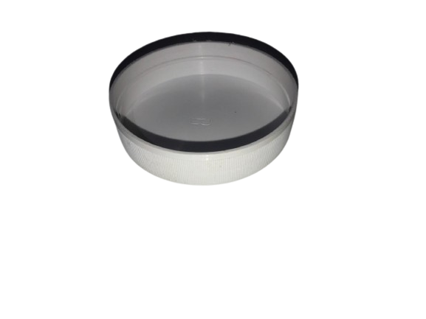

Figure 4- 1 Container have same diameter as the rainfall sensor funnel

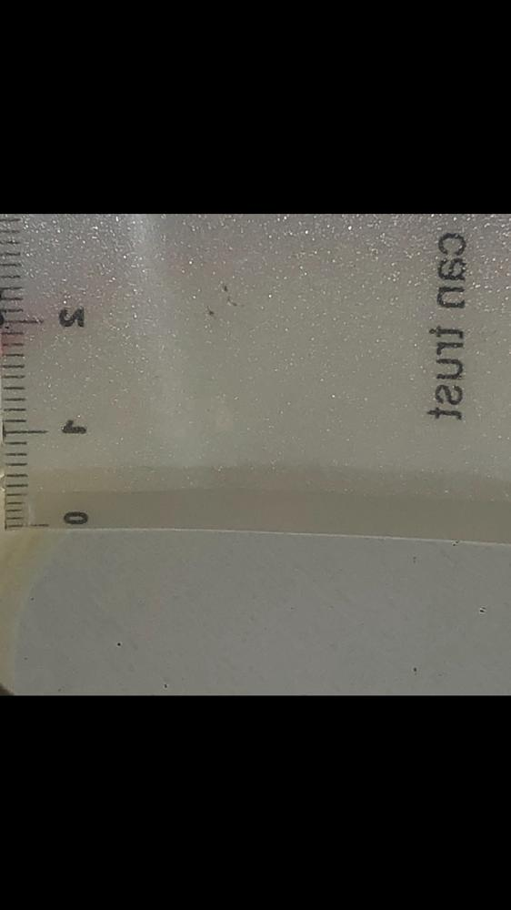

Figure 4- 2: Water measurement



Figure 4- 3: The Resulting Readings

### Wind Speed Sensor

Measuring wind speed posed a significant challenge, particularly due to the necessity for high accuracy in handling the components. During sensor installation, an error occurred, resulting in a slight tilt in the pole supporting the sensor. While this error did not significantly impact the sensor's overall functionality, it did affect its ability to accurately read very low wind speeds, particularly in the range of 0 to 3 kilometers per hour. As we previously noted, the absence of a reference to determine wind speed at the output voltage prompted us to utilize a hair dryer with four distinct speed settings. The voltage values corresponding to each speed setting are outlined in the following table:

|  |  |  |
| --- | --- | --- |
| Hair Dryer speed | ADC | Vout |
| 1 | 92 - 122 | 0.4492 - 0.5957 |
| 2 | 184 - 245 | 0.8984 - 1.1963 |
| 3 | 337 - 428 | 1.6445 - 2.0898 |
| 4 | 500 - 572 | 2.4414 - 2.7920 |

Table 4- 1: Vout Values for Wind Speed

### GPS Location

Determining the geographical location using GPS yielded precise results when plotted on the map. The NEO-6M GPS module was connected to the hardware serial port. However, due to the limitation of the Arduino Uno, which does not support multiple software serial connections simultaneously, we opted to utilize the hardware serial port exclusively for the GPS module. This decision was made to avoid potential conflicts and confusion with other serial devices, such as the XBee module, which also requires serial communication.

### Humidity abd temperature Sensors

In terms of measuring temperature and humidity, we compared the values with those obtained from a weather prediction application. Our analysis showed that the readings from our sensors closely matched those provided by the application. However, occasional discrepancies of a degree were noted, likely due to variations in measurement locations. which may have contributed to these slight differences in readings.

|  |  |  |  |  |
| --- | --- | --- | --- | --- |
| Time | Unit Sensors | | Weather Application | |
| ---------- | Temperature | Humidity | Temperature | Humidity |
| 2:50 PM | 16.30° | 71% | 16° | 71% |
| 3:30 PM | 15.70° | 71% | 15° | 71% |
| 4:00 PM | 15.50° | 72% | 15° | 72% |
| 4:15 PM | 14.12° | 73% | 14° | 73% |
| 5:10 PM | 13.49° | 77% | 13° | 77% |

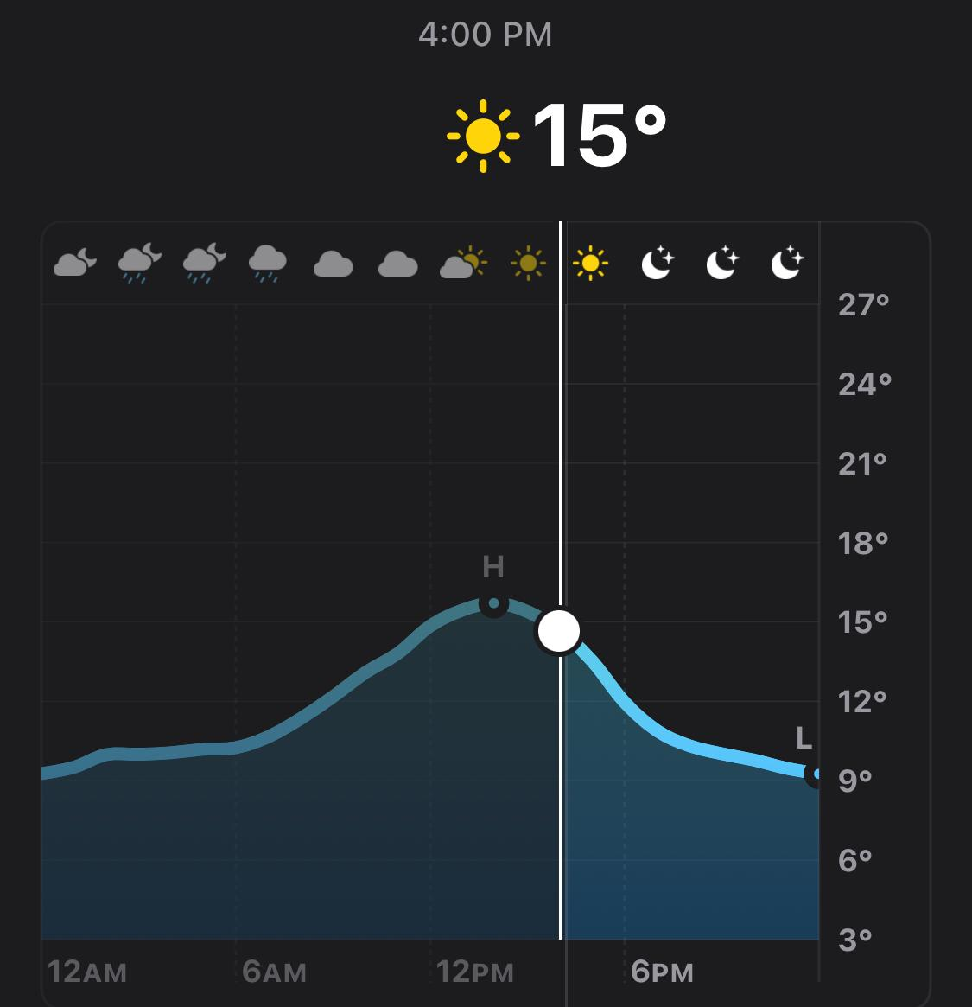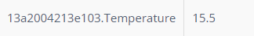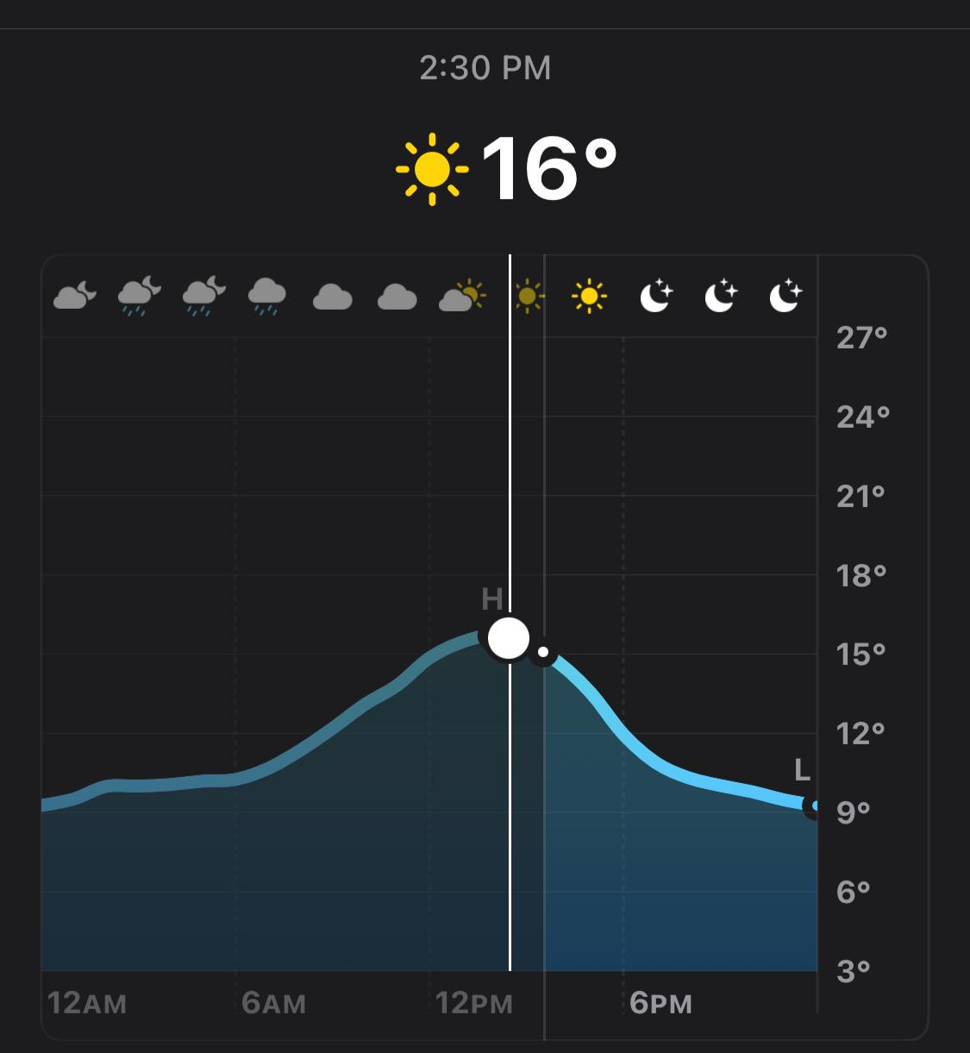

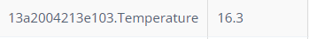

Figure 4- 4: Temperature at 2:30 PM Figure 4- 5: Temperature at 4:00 PM

### Mesh Network

Regarding the network functionality, all previously discussed features operated efficiently, and data transmission occurred without any loss of readings. Commands issued by the main unit to other units yielded excellent results. Additionally, we conducted tests to verify if the main unit could successfully check the status of other units within the network. Our comprehensive testing encompassed various scenarios like the mentioned in other features section.

### power

Operating the Arduino and all sensors using rechargeable lithium batteries proceeded seamlessly. To determine the duration of battery operation, we compared the power consumption of each sensor to the capacity of the batteries. With each battery boasting a capacity of 2700mA, and two batteries combined providing 5400mA, the total consumption of the entire sensor unit was approximately 170mA. Hence, the unit can operate on batteries for approximately 31.8 hours, with the potential to extend this period by increasing the battery capacity.

In terms of measuring the percentage of energy remaining in the batteries, it's essential to ascertain the voltage drop experienced as the batteries discharge. Although we have yet to fully discharge the batteries, we approximated a voltage of 3.2 volts for each battery, indicating a total voltage of 6.4 volts when both batteries are depleted. Utilizing pin A2, we read the voltage, and subsequently employ the map function to convert the voltage range between 7.4 and 6.4 volts into a percentage value ranging from 0 to 100. This approach enables us to accurately gauge the remaining energy levels in the batteries.

### Stored Data in the cloued

The readings were meticulously stored on the website, showcasing an exemplary organizational structure. We successfully presented the readings in various formats, as depicted in the accompanying images.

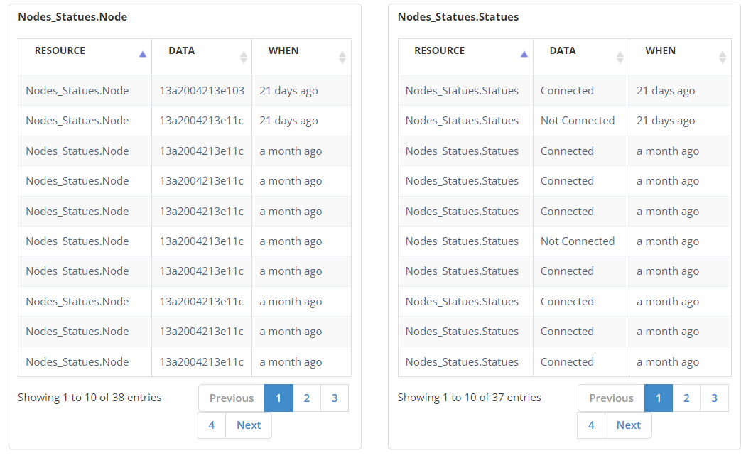

Figure 4- 6: Data Visualization

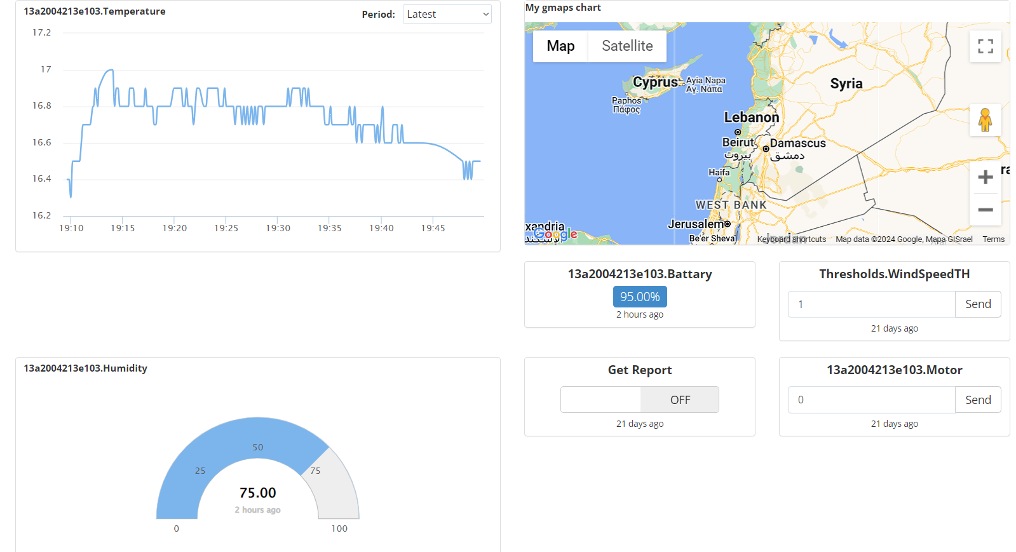

Figure 4- 7: Data Visualization

* 1. Discussions

To enhance the accuracy of the wind sensor despite the tilt present in the pole, we propose utilizing a magnet attached to the pole in conjunction with a Hall effect sensor. This sensor operates similarly to a DC motor but is influenced by magnetic fields. As the magnet passes the sensor, it triggers a cycle, allowing us to track the number of cycles over a specified period. By analyzing these cycles, we can derive a more precise measurement of wind speed, thereby achieving a higher level of accuracy in our readings.

We previously addressed the challenge of storing readings in the event of transmission or database upload issues. Storing readings in Arduino's RAM, although expedient, poses a risk of data loss due to its volatile nature. To mitigate this risk, we proposed a solution involving the use of an external storage memory, such as an SD card. This option offers a reliable means of preserving data.

We kept adding the external memory an optional choice, as we encapsulate and queue the data in both cases (Whether there is an external storage memory or not) the remaining process is to write and read the data from the external memory, integrating an SD card is a straightforward process, we opted for the SD card due to its compatibility with the I2C protocol, which operates on pins A4 and A5 in the Arduino, ensuring seamless integration into our system architecture.

1. **CHAPTER 5: Project Management**
   1. Tasks, Schedule, and Milestones

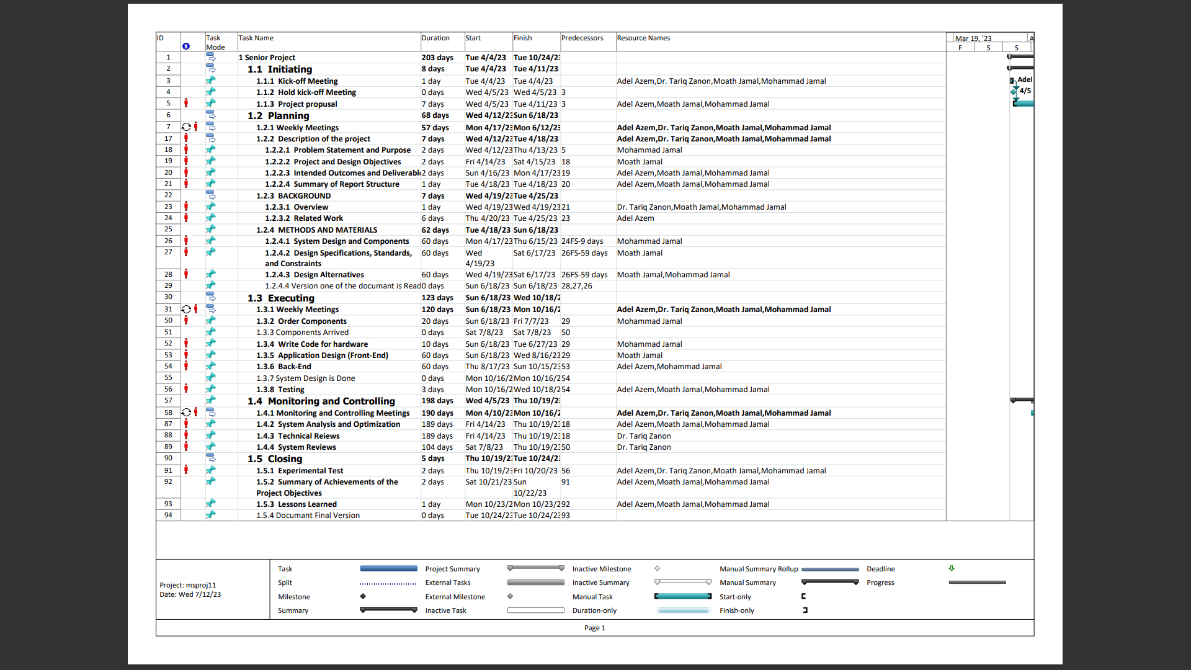

Figure 5- 1: Gantt Chart and TimeLine

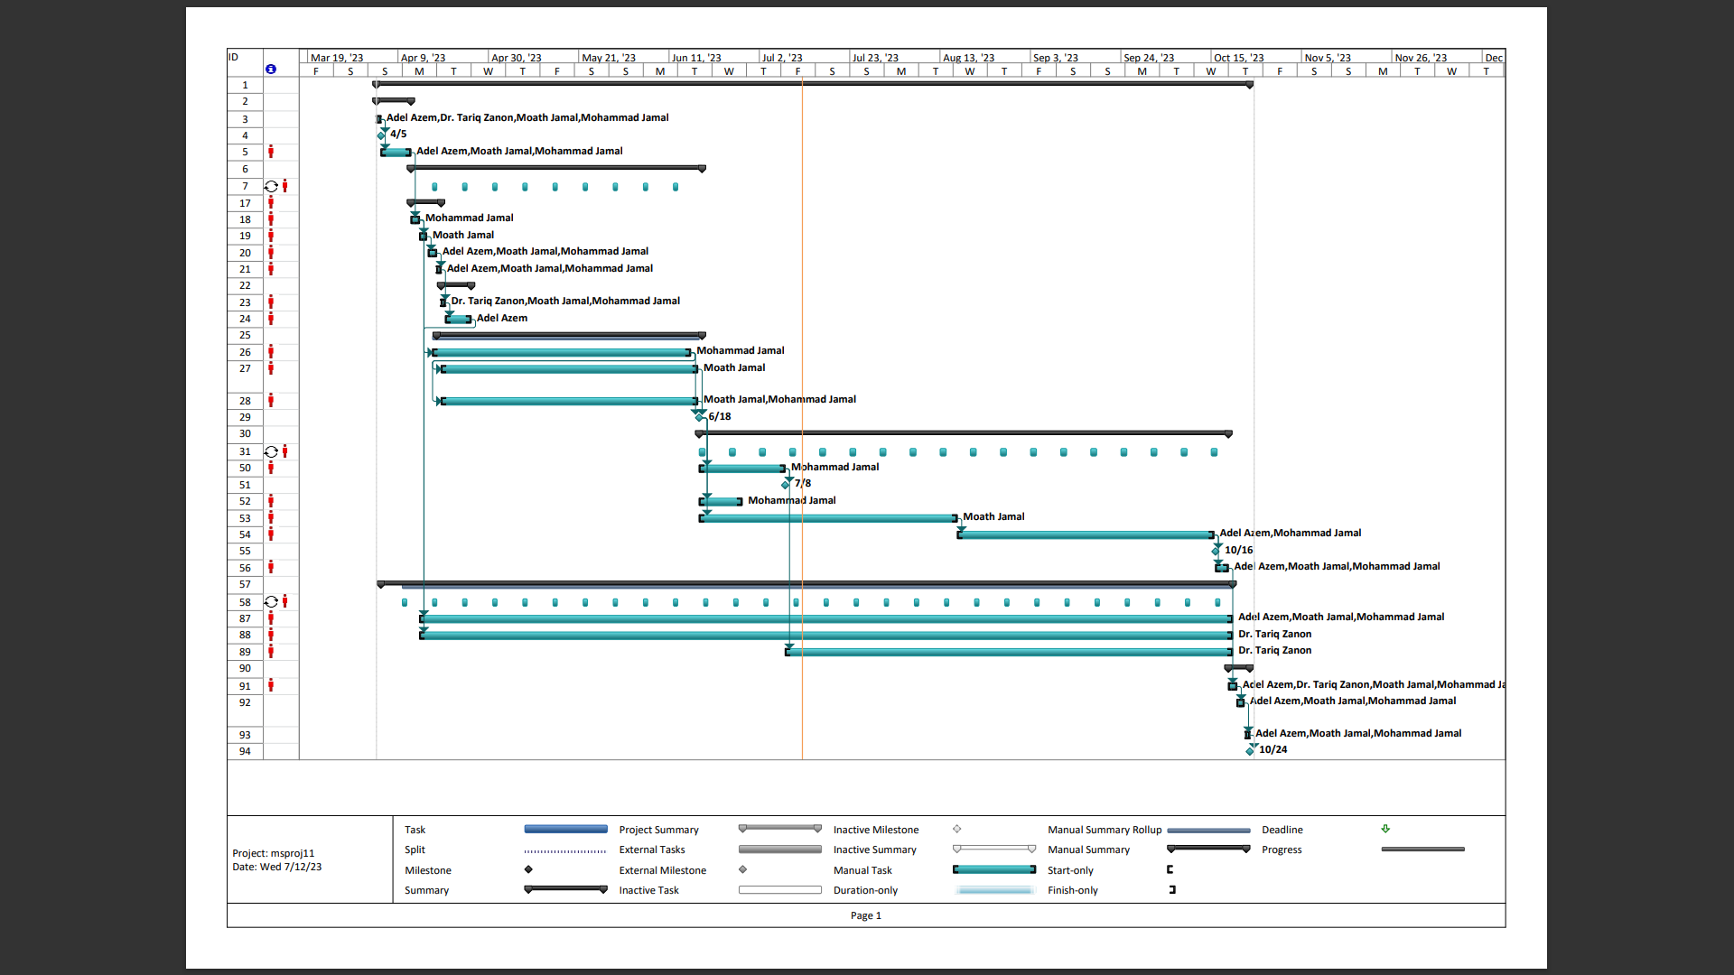

Figure 5- 2: Gantt Chart and TimeLine

* 1. Resources and Cost Management

|  |  |  |  |
| --- | --- | --- | --- |
| Item | # Unit | Unit Cost | Subtotals |
| Arduino Uno | 2 | 10 $ | 20 $ |
| Arduino Uno Wi-Fi | 1 | 10 $ | 10 $ |
| Data logger | 1 | 2 $ | 2 $ |
| XBee S2C | 3 | 52 $ | 156 $ |
| Tipping Bucket | 1 | 20 $ | 20 $ |
| C2192 Anemometer | 1 | 20 $ | 20 $ |
| NEO-6M GPS receiver | 1 | 15 $ | 15 $ |
| Temperature Sensor | 1 | 3 $ | 3 $ |
| Humidity Sensor | 1 | 3 $ | 3 $ |
| Solar Power System | 1 | 3 $ | 3 $ |
| Total senior project estimate |  |  | 261 $ |

Table 5- 1: Resources and Cost

* 1. Lessons Learned

**Effective Collaboration:** The project showcased exceptional teamwork and communication, especially during critical phases like hardware integration and code development.

Regular team meetings and open channels of communication contributed to the project's overall success.

**Optimizing Timeline Management:** The project experienced minor delays in hardware delivery, highlighting the importance of refined timeline management.

Future projects can benefit from enhanced contingency planning to mitigate the impact of unforeseen challenges.

**Adaptability:** The team exhibited adaptability when circumstances, like delays in hardware availability, required adjustments to the project timeline.

Flexibility in adapting to unforeseen circumstances played a crucial role in maintaining project momentum.

**Technical Skill Enhancement:** The project witnessed substantial enhancements in technical skills, particularly in Arduino coding, hardware integration, and the utilization of XBee modules. Key milestones were reached as the team acquired and applied new technologies integral to accomplishing the project's objectives.

**Key Takeaways:** The project provided valuable insights into effective collaboration, adaptability, and technical skill development.

The importance of anticipating and addressing external factors impacting project timelines was underscored.

1. **CHAPTER 6: Impact of the engineering solution**
   1. Economical, Societal, and Global

The dependence of weather data collection units on solar energy mainly fills the need for electricity supply, which reduces operating costs.

Knowing the places where there is the most wind and the most exposure to sunlight helps in installing renewable energy stations, and this would increase the efficiency of the amount of renewable energy extracted.

It is worth paying attention to the cost-saving aspects that draw attention to the product, especially if it offers advantages over alternative solutions. For example, paying attention to the energy-saving feature of your modules will attract customers who seek to reduce energy consumption and operating costs.

Weather data collection units do not contain rare, strictly controlled, or expensive materials.

All materials are available in the market and have an acceptable price, and this would enhance the marketability of the product

We know the agriculture sector is one of the sectors that suffer from difficult living conditions. The developed product can have a positive impact on people's lives. By providing real-time weather data, keeping farmers informed about the weather allows them to improve the performance of the agricultural sector. With constant knowledge of the weather, farmers can improve irrigation, pest management, and crop planning, leading to higher productivity and better livelihoods.

The construction and maintenance of the project will create business opportunities in areas such as sensor manufacturing, system installation and maintenance, analytics, and application development.

The demand for skilled professionals in these fields can lead to job growth and the development of new areas.

* 1. Environmental and Ethical

Providing the product with solar energy to operate it effectively contributes to reducing greenhouse gas (GHG) emissions. By utilizing renewable energy rather than relying on fossil fuels, the product helps mitigate the environmental impact associated with power generation. This shift towards clean energy sources can help combat climate pollution and global warming and improve air quality.

The product has the ability to positively affect overconsumption by rationalizing the use of resources more efficiently. This is done by providing farmers with accurate weather data and knowing the times and quantity of rain, and this enables farmers to improve water use.

The product is manufactured from easy and recyclable materials that do not emit any radiation harmful to the environment or harmful components, and the components are recyclable, which will preserve the environment.

1. **CHAPTER 7: CONCLUSIONS and RECOMMENDATIONS**
   1. Summary of Achievements of the Project Objectives

Our goal was to create a network of solar-powered weather modules, and we achieved this by designing a flexible system where modules can communicate with each other and be added or removed easily. We utilized a natural power supply to ensure a long power charge. The collected data is then sent to a user interface, providing visualizations, maps, and graphs.

### Build a Weather Monitoring Module with Solar-Powered Mobile Units

#### Sensor Integration:

Design and meticulously assemble sensor modules (temperature, humidity, rainfall, wind speed) with precise interfacing to an Arduino Uno microcontroller.

#### Wireless Communication:

Ensure seamless integration of XBee wireless communication modules for real-time data transmission and networking capabilities, utilizing Zigbee protocol and mesh topology.

#### Geographical Positioning:

Integrate a sophisticated Global Positioning System (GPS) for accurate geographical location determination, enhancing data mapping capabilities.

#### Solar Power Implementation:

Implement a robust solar power system incorporating cutting-edge solar panels and efficient batteries to ensure continuous functionality even in varying environmental conditions.

### **Develop an application for real-time data visualization.**

Navigating obstacles, we made a strategic decision to utilize an existing web-based solution for quasi real-time data visualization. It's important to note that this platform wasn't specifically tailored for our project; however, it provided a functional framework to showcase weather data, maps, and statistical charts. This approach was chosen considering the limitations and circumstances faced in the country, which impeded the creation of a custom integrated application. It allowed us to effectively present project data according to our needs and objectives.

### **Ensure seamless communication network.**

Implemented modules with XBees using Zigbee protocol, enabling strong communication between modules. Set up a mesh network with automatic recovery (self-healing) and adaptive configurations (self-configuring). This ensures reliable communication even if nodes fail and allows for automatic adjustments in response to changes or network modifications.

* 1. **New Skills and Experiences Learnt**

Navigating obstacles, we made a strategic decision to utilize an existing web-based solution for quasi real-time data visualization. It's important to note that this platform wasn't specifically tailored for our project; however, it provided a functional framework to showcase weather data, maps, and statistical charts. This approach was chosen considering the limitations and circumstances faced in the country, which impeded the creation of a custom integrated application. It allowed us to effectively present project data according to our needs and objectives.

* 1. **Recommendations for Future Work**

Implemented modules with XBees using Zigbee protocol, enabling strong communication between modules. Set up a mesh network with automatic recovery (self-healing) and adaptive configurations (self-configuring). This ensures reliable communication even if nodes fail and allows for automatic adjustments in response to changes or network modifications.

|  |  |
| --- | --- |
| [1] | N. Miller, "How are weather forecasts made?," 18 February 2020. [Online]. Available: https://www.bbc.com/news/explainers-51533852. [Accessed 26 May 2023]. |
| [2] | Han-Lim Choi; Jonathan P. How, "Coordinated Targeting of Mobile Sensor Networks for Ensemble Forecast Improvement," 1 March 2011. [Online]. Available: https://ieeexplore.ieee.org/abstract/document/5585654/keywords#keywords. |
| [3] | N. U. D. o. Commerce, "Citizen Weather Observer Program," 8 July 2019. [Online]. Available: https://www.weather.gov/cle/CWOP. |
| [4] | Amazon.com:, "Amazon.com: Netatmo Weather Station Indoor outdoor with wireless ...," Amazon.com:. [Online]. |
| [5] | G. d. "FROGGIT HP1000SE PRO," METEOCULTURA, 03 November 2022. [Online]. Available: https://estaciondemeteorologia.com/froggit-hp1000se-pro-misol-hp2550-estacion-meteorologica-wifi-con-pantalla-grafica/. [Accessed 26 May 2023]. |
| [6] | G. a. T. J. Solano, "Monitoring weather parameters from difficult access places," 2019 IEEE XXVI International Conference on Electronics, Electrical Engineering and Computing (INTERCON), 2019. [Online]. Available: https://ieeexplore.ieee.org/document/8853801. [Accessed 27 May 2023]. |
| [7] | P. Instruments, "IMETOS 3.3 – METOS® by Pessl Instruments," Pessl Instruments, [Online]. Available: https://metos.at/en/imetos33/. [Accessed 27 May 2023]. |
| [8] | meteomatics, "Weather forecast with Meteodrones Weather Drones," meteomatics, [Online]. Available: https://www.meteomatics.com/en/meteodrones-weather-drones/. |
| [9] | Wikipedia, "Arduino Uno," Wikimedia Foundation, 9 Mar 2023. [Online]. Available: en.wikipedia.org/wiki/Arduino_Uno. [Accessed 2 May 2023]. |
| [10] | A. Dialogue, "UART," [Online]. Available: https://www.analog.com/en/analog-dialogue/articles/uart-a-hardware-communication-protocol.html. [Accessed 6 June 2023]. |
| [11] | JD_K and Instructables, "Arduino data logging shield with real time clock timestamp ... and Telemetry, sensor network," Instructables, 10 Aprill 2023. [Online]. Available: https://www.instructables.com/Arduino-Data-Logging-Shield-With-Real-Time-Clock-T/. [Accessed 27 May 2023]. |
| [12] | Solarduino, "How to use Datalogger shield?," Soalrduino, 12 January 2020. [Online]. Available: https://solarduino.com/how-to-use-datalogger-shield-with-arduino/. [Accessed 27 May 2023]. |
| [13] | "What is a tipping bucket rain gauge, and how does it work?," OroCommerce, [Online]. Available: https://www.instrumentchoice.com.au/news/what-is-a-tipping-bucket-rain-gauge-and-how-does-it-work. [Accessed 12 May 2023]. |
| [14] | "Tipping bucket rain gauge," WeatherShack.com, [Online]. Available: https://www.weathershack.com/static/ed-tipping-bucket-rain-gauge.html. [Accessed 12 May 2023]. |
| [15] | "Low-cost weather monitoring system with online logging and data ...," [Online]. Available: https://www.researchgate.net/publication/304297354_Low-cost_weather_monitoring_system_with_online_logging_and_data_visualization. |
| [16] | Wikipedia, "Anemometer," Wikimedia Foundation, 4 Apr 2023. [Online]. Available: en.wikipedia.org/wiki/Anemometer. [Accessed 29 Apr 2023]. |
| [17] | "Anemometers for Air Flow Measurement," 15 October 2018. [Online]. Available: https://www.coleparmer.com/tech-article/airflow. [Accessed 2 June 2023]. |
| [18] | W. F. Wikipedia, "IEEE 802.15.4," 12 April 2023. [Online]. Available: https://en.wikipedia.org/wiki/IEEE_802.15.4. [Accessed 8 June 2023]. |
| [19] | Digi, "Components101 - electronic components pinouts, details & datasheets," [Online]. Available: https://components101.com/sites/default/files/component_datasheet/Xbee%20S2C%20Module%20Datasheet.pdf. [Accessed 9 June 2023]. |
| [20] | M. topology, "Mesh Topology | Sunbird DCIM," [Online]. Available: https://www.sunbirddcim.com/glossary/mesh-topology. [Accessed 12 May 2023]. |
| [21] | T. A. Team, "Getting started with the Arduino Uno WIFI," 4 July 2023. [Online]. Available: https://docs.arduino.cc/retired/getting-started-guides/ArduinoUnoWiFi. |
| [22] | "Ublox NEO-6M GPS module," Wiki, [Online]. Available: http://wiki.sunfounder.cc/index.php?title=Ublox_NEO-6M_GPS_Module. [Accessed 9 June 2023]. |
| [23] | D.-K. Electronics, "U-blox 6 GPS modules Te - Digi-Key Electronics," [Online]. Available: https://www.digikey.com/htmldatasheets/production/2757457/0/0/1/NEO-6.pdf. [Accessed 9 June 2023]. |
| [24] | L. M. Engineers, "In-depth: Interface ublox NEO-6M GPS module with Arduino," Last Minute Engineers, 26 June 2022. [Online]. Available: https://lastminuteengineers.com/neo6m-gps-arduino-tutorial/. [Accessed 9 June 2023]. |
| [25] | M. Integrated, "Ds18b20," [Online]. Available: https://www.analog.com/media/en/technical-documentation/data-sheets/DS18B20.pdf. [Accessed 5 June 2023]. |
| [26] | A. Electronics. [Online]. Available: https://www.sparkfun.com/datasheets/Sensors/Temperature/DHT22.pdf. [Accessed 5 June 2023]. |
| [27] | "Temperature - clinical methods - NCBI bookshelf," [Online]. Available: https://www.ncbi.nlm.nih.gov/books/NBK331/. [Accessed 16 July 2023]. |
| [28] | W. F. Wikipedia, "IEEE 802.11," 13 July 2023. [Online]. Available: https://en.wikipedia.org/wiki/IEEE_802.11. [Accessed 14 July 2023]. |
| [29] | E. Britannica, "Satellite Communication," Encyclopædia Britannica, inc., 29 May 2023. [Online]. Available: https://www.britannica.com/technology/satellite-communication. [Accessed 7 June 2023]. |
| [30] | C. Pierre, "Guide for DS18B20 temperature sensor with Arduino," Random Nerd Tutorials, 16 July 2019. [Online]. Available: https://randomnerdtutorials.com/guide-for-ds18b20-temperature-sensor-with-arduino/. [Accessed 17 July 2023]. |
| [31] | M. Afzal, "Temperature monitoring with DHT22 & arduino," Hackster.io, 08 October 2022. [Online]. [Accessed 2023]. |
| [32] | D. Pankhurst, "Utopia Mechanicus," 28 July 2011. [Online]. Available: https://www.utopiamechanicus.com/article/arduino-photo-interruptor-slotted-optical-switch/. [Accessed 17 July 2023]. |
| [33] | "Arduino Xbee Tutorial," [Online]. Available: https://circuitdigest.com/microcontroller-projects/arduino-xbee-module-interfacing-tutorial. [Accessed 10 February 2024]. |
| [34] | ElectronicWings, "Xbee S2 (Zigbee) interfacing with Arduino Uno: Arduino," [Online]. Available: https://www.electronicwings.com/arduino/xbee-s2-zigbee-interfacing-with-arduino-uno. [Accessed 10 February 2024]. |
| [35] | btechsol, "Tipping bucket rain gauge by btechsol," [Online]. Available: https://www.thingiverse.com/thing:4434857. [Accessed 11 Februray 2024]. |
| [36] | Firstrate, "Wind Sensor_ Hunan Firstrate Sensor Co.,Ltd," Wind Sensor, [Online]. Available: https://www.firstratesensor.com/product.html?introId=32&gclid=CjwKCAjwscGjBhAXEiwAswQqNFO-tL_25hDPDH1eVajYZ-wZDjPpQOPbFUxKvi5y_Pjdc2cl2O8aPRoC9gYQAvD_BwE. [Accessed 27 May 2023]. |
| [37] | H. Q. E. T. Co, "QS-FS ⊙技术参数 - adafruit industries," adafruit industries, [Online]. Available: https://cdn-shop.adafruit.com/product-files/1733/C2192+datasheet.pdf. [Accessed 6 June 2023]. |